INTERNET-OF-THINGS INVENTORY MANAGEMENT SYSTEM FOR

ULTRA-LOW BIOFREEZER IN MQTT FRAMEWORK

An Undergraduate Thesis

Presented to the Faculty of the

College of Information and Communications Technology

West Visayas State University

La Paz, Iloilo City

In Partial Fulfillment

of the Requirements for the Degree

Bachelor of Science in Information Technology

by

Ayrra Jane R. Amio

Mc Kelly D. Castro

Winston C. Sevilla

Paul Adrian D. Soncio

Jose Mari C. Wong

June 2022Approval Sheet

INTERNET-OF-THINGS INVENTORY MANAGEMENT SYSTEM FOR

ULTRA-LOW BIOFREEZER IN MQTT FRAMEWORK

An Undergraduate Thesis for the Degree

Bachelor of Science in Information Technology

by

Ayrra Jane R. Amio

Mc Kelly D. Castro

Winston C. Sevilla

Paul Adrian D. Soncio

Jose Mari C. Wong

Approved:

DR. EVANS B. SANSOLIS

Adviser

PROF. CYRENEO S. DOFITAS JR. DR. MA. BETH S. CONCEPCION

Chair, Information Technology Dean, CICT

June 2022

# Acknowledgment

This research paper will not be possible without the guidance of various people who never failed to support the researchers in every endeavor especially during the conduct of the study.

Their parents and guardians, Mr. Loijie Amio, Mrs. Edelyn Amio, and Mrs. Rosemarie Amio Aclaro, Mrs. Mary Ann D. Castro, Mrs. Georgina C. Sevilla, Mrs. Jacqueline Wong, and Mr. Benedict Wong, Mrs. Lolita D. Soncio, and Mr. Ronnie G. Soncio, for the financial, emotional and moral support that they had offered since the day of their research study;

Dr. Evans B. Sansolis, thesis adviser, for all the help, guidance, and patience;

Mr. Shem Durst Elijah Sandig and Mr. Ralph Voltaire Dayot, for the help, advice, and valuable ideas they gave.

Dr. Ma. Beth Concepcion and Mr. Cyreneo Dofitas Jr. and the rest of the faculty and staff of College of Information and Communications Technology, for their helping hand and limitless support;

That friend, for the help, knowledge, support, time, accommodation to his home, and encouragement he gave to the group;

BSIT 4A, for their emotional and financial support;

The West Visayas State University, for allowing them to experience IT Training and for molding them to become responsible citizens of the society;

All these things will never be possible without the guidance of the Almighty God. To God be the Glory!

To all of them, this humble work is heartily dedicated.

Ayrra Jane R. Amio

Mc Kelly D. Castro

Winston C. Sevilla

Paul Adrian D. Soncio

Jose Mari C. Wong

June 2022

Amio, Ayrra Jane R.; Castro, Mc Kelly D.; Sevilla, Winston C.; Soncio, Paul Adrian D.; Wong, Jose Mari C.:” Internet-of-Things Inventory Management System for Ultra-Low Biofreezer in MQTT Framework”. Unpublished Undergraduate Thesis, Bachelor of Science in Information Technology, West Visayas State University, Iloilo City, Philippines, June 2022.

# 

# Abstract

With the increasing number of specimens being stored inside Ultra-Low Biofreezers, the Biological and Physical Sciences Department of the West Visayas State University needs a systematic and reliable way of monitoring inventory and the fluctuation of the temperature inside the biofreezer. Thus, this study aimed to develop an Internet-of-Things Inventory Management System to manage the biospecimen materials in Ultra-Low Biofreezers. The system is composed of an ESP8266 NodeMCU microcontroller and a K-type thermocouple sensor with a MAX6675 module. The researchers utilized a QR Code - integrated Inventory Management Mobile Application with the Cayenne MQTT Service for user notification via email and SMS in case of sudden temperature fluctuations. The system can monitor temperature and record data logs inside the biofreezers. It can also generate a record of inventory load in and load outs, fluctuations and manifesto reports.

The system was implemented, tested, and evaluated based on usability and effectiveness using the ISO/IEC 25010:2011 Systems and Software Quality Requirements. The Biological and Physical Sciences Department should use the system to assist laboratory personnel to show efficiency in the department’s monitoring process for compliance with good laboratory practice.

# Table of Contents

Title Page

Approval Sheet ii

Acknowledgement iii

Abstract v

Table of Contents vii

List of Figures ix List of Tables xi

List of Appendices xii

Chapter

1 Introduction to the Study Background of the Study and Theoretical 1 Framework 3

Objectives of the Study 4

Significance of the Study 6

Definition of Terms 7

Delimitation of the Study 12

2 Review of Related Studies

Review Of Existing and Related Studies 14

3 Research Design and Methodology

Description of Proposed Study 18

Methods and Proposed Enhancements 19

Components and Design 22

System Architecture 22

Database Design 24

Procedural Design 27

Object-Oriented Design 36

Process Design 38

System Development Life Cycle 42

4 Results and Discussion

Implementation 48

Results Interpretation and Analysis 63

System Evaluation Results 66

5 Summary, Conclusions and Recommendations Summary of the Proposed Study Design and Implementation 70

Summary of Findings 71

Conclusion 73

Recommendations 76

References 78

Appendices 83

List of Figures

Figure Page

1 Conceptual Framework 3

2 System Architecture 23

3 Database Tables of the System 24

4 Flowchart of the proposed standalone web

system for admin 29

5 Flowchart of the proposed Bio Lab mobile

application 31

6 Flowchart of the QR Scanner 33

7 Flowchart of the Temperature Data 34

8 Flowchart of the Inventory Data 35

9 Use Case Diagram 37

10 Context Diagram of the System 40

11 Level 1 Bio Lab Standalone Web System 41

12 Level 1 Bio Lab Mobile Application 42

13 Scrum Agile Method 43

14 IoT Device thermocouple probe 50

15 Web Login Page 51

16 Web Registration Page 51

17 Mobile Application Login Page 52

List of Figures

Figure Page

18 Web Add Item Inventory Page 53

19 Web QR Generation 54

20 Mobile Application QR Scanner 55

21 Mobile Application Main Menu Page 56

22 Mobile Application Inventory Page 57

23 Mobile Application Temperature Data Page 58

24 Inventory Log Report 59

25 Inventory Item Load in and out Report 59

26 Temperature Data Log Report 60

27 User Notification through SMS and Email

by the Cayenne MQTT Service 65

List of Tables

Table Page

1 Temperature over time inside the consumer

grade refrigerator 64

2 Mean Scale System 66

3 Evaluation Results for the Proposed System 68

List of Appendices

Appendix Page

1. Letter to the Adviser 84
2. Letter to the English Editor 86
3. ISO 9126 Software Quality Evaluation

Questionnaire 87

1. Certificate of Completion and Acceptance 89
2. Gantt Chart 90
3. Entity-Relationship Diagram 91
4. Data Dictionary 92
5. Circuit Diagram 94
6. Sample Program Codes 95

CHAPTER 1 INTRODUCTION TO THE STUDY

Background of the Study and Theoretical Framework

Researchers rely on cold equipment such as Ultra-low Biofreezers to maintain the quality of biospecimens. In most laboratory assessments, biospecimens are preserved in ultra-low freezers where temperatures can drop to -80°C. Nonetheless, the quality of these specimens can be disturbed and influenced by the fluctuation in the temperature within these Ultra-low storage units (Powell et al., 2019). The Ultra-low Biofreezer is one of the most important tools used in the laboratory. The biofreezer protects the biological sample by keeping it at a very low temperature. The failure of it not only results in significant financial loss, but can also endanger samples that disrupt critical research.

With the increasing number of biospecimens being stored and monitored inside these Ultra-low storage units, there will be a higher need for a reliable and systematic way to handle these stored specimens (Shukran et al., 2017). In addition to this, an IoT Inventory Management System based on emerging technology to manage the biospecimen in an Ultra-low Biofreezer will be included in the development of the study. It will also prevent frequent manual handling of biospecimens, as they require biofreezers to be opened temporarily, risking the integrity of biospecimen quality (Powell et al., 2019).

In this research, the main idea is to develop a functional IoT inventory management system for the Biological and Physical Sciences Laboratory of West Visayas State University, to manage the biospecimens in Ultra-low Biofreezers. Figure 1 shows the conceptual framework of the said study. The study is composed of inputs, processes and outputs. The system starts as the thermocouple sensor device installed in the biofreezer sends temperature data to the database and the Cayenne MQTT Service Broker through the IoT gateway. As for the temperature monitoring and inventory management inside the biofreezer, a mobile application is developed by the researchers in order to output the data stored in the database. A Standalone Web System was also made for the Registration, Adding of Item Inventory and QR Generation. The data from the sensor is processed on the Cayenne Service Broker. If fluctuation is detected, it will send an SMS alert or email notification to the admin. The admin will be the Laboratory Head while the users will be the Research Facilitators of the Biological and Physical Sciences Department of West Visayas State University.



*Figure 1.* Conceptual Framework

Objectives of the Study

This study generally aims to develop anIoT Inventory Management System based on emerging technology to manage the biospecimen in an Ultra-low Biofreezer.

Specifically, it aims to:

1. Develop a Biospecimens Inventory Management Mobile Application integrated with QR code Technology for an inventory of biospecimens inside Ultra-Low Biofreezers and real-time temperature monitoring.

2. Develop an IoT device using ESP8266 Node MCU that will be able to continuously send temperature data to Biospecimens Inventory Management Mobile Application.

3. Integrate a User Notification System using MQTT Framework and SMS Technology for user notification in an event of sudden temperature fluctuations in Ultra-Low Biofreezers.

4. Implement and test the IoT Inventory Management System, and finally evaluate based on usability and effectiveness using ISO-standard Usability Evaluation Tools.

Significance of the Study

The results of this study will be beneficial to the following:

Biological and Physical Sciences Department of West Visayas State University. Temperature data given will provide efficiency in the department’s monitoring process to gather data for compliance for good laboratory practice.

Faculty Researchers and Laboratory Head. The development of the device in the study will help them in managing inventory and monitoring the temperature inside the biofreezer without going to the lab physically. It will also provide efficiency in the department’s monitoring process to gather data for compliance for a good laboratory practice.

College of Information and Communications Technology. This study will improve the college in the development of Information Communications Technology education. This study will foster new ways of enhancing knowledge and skills in ICT, thus preparing globally competitive technology students in the future.

Future Researchers. This study will encourage students to apply the knowledge and skills they have obtained in both areas of hardware and software. This study will contribute to areas where temperature monitoring is required.

Definition of Terms

For better understanding, the following terms were defined conceptually and operationally:

*Arduino Integrated Development Environment (IDE)* -- is a text editor for writing code and contains a message area, a text console, a toolbar with buttons for common functions, and a series of menus. (Arduino Integrated Development Environment, 2021).

In this study, “Arduino Integrated Development Environment (IDE)” refers to the text editor used for the code construction on the microprocessor.

*Biospecimen --* is any natural material from a living organic body, such as tissue, blood, and urine (University of California, 2021).

In this study, "Biospecimen" refers to the samples inside the biofreezer.

*Cayenne MQTT* -- MQTT is the preferred transport and API for sending data to the Cayenne Cloud, or for devices that receive commands from Cayenne (Del C., 2021).

In this study, Cayenne MQTT acts as a broker, managing the various sensor and actuator client devices that wish to send and receive data using the Cayenne Cloud.

*I2C LCD Adapter* -- A typical I2C LCD consists of an HD44780 based character LCD and an I2C LCD adapter (Lastminuteengineers.com, 2020).

In this study, the "12C LCD Adapter" refers to the LCD used in the development of the device that will show the current temperature of the biofreezer.

*The MAX6675* -- a sophisticated thermocouple-to-digital converter with a built-in 12-bit analog-to-digital converter (ADC). (Maxim Integrated, 2021).

In this study, "MAX6675" refers to the sensor amplifier module used in conjunction from the thermocouple to the microcontroller.

*MQTT protocol (Message Queuing Telemetry Transport)* -- is a lightweight messaging protocol that was developed by IBM. It uses the pub/sub pattern and translates messages between devices, servers, and applications (Spofford, 2019).

In this study, “MQTT protocol” refers to the communications satellites to link the sensor on the Ultra-Low Biofreezer with an emphasis on minimal battery loss and bandwidth consumption.

*My Structured Query Language (MySQL)* -- is a freely available open-source Relational Database Management System (RDBMS) that uses Structured Query Language (SQL) (Siteground Hosting LTT, 2021).

In this study, “MySQL” was the database management system used by the researchers for storing data.

*NodeMCU* -- is an open-source Lua-based firmware and development board specially targeted for IoT-based Applications. (Components101, 2021).

In this study, “NodeMCU” refers to the microprocessor used in the development of the device.

*NodeMCU Base Board* -- It extends the GPIO of NodeMCU to header pins, which also includes the Vin, VUSB, 5V, 3.3V, and GND. It can be further used for prototyping, with the male to female jumper wires (Factoryforward, 2021).

In this study, "NodeMCU Baseboard" refers to the expansion board used in developing the device to ease prototyping.

*Notification* -- a written or printed matter that gives notice (Merriam-Webster, n.d., 2021).

In this study, “Notification” refers to the notice sent to the user’s mobile phone.

*QR code* -- A quick response (QR) code is a type of barcode that can be read easily by a digital device and which stores information as a series of pixels in a square-shaped grid (Hayes, 2021).

In this study, “QR code” refers to the type of barcode to be scanned from the vials that contain samples inside the biofreezer.

*Scrum Methodology* -- Scrum is an adaptable, fast, flexible and effective agile framework that is used in the development of Software based on iterative and incremental processes. (Digite, Inc., 2022).

In this study, the “Scrum Methodology” will be the agile framework chosen by the researchers to be adapted in the development of the project.

*Thermocouple* -- A thermocouple is a simple, robust, and cost-effective temperature sensor used in a wide range of temperature measurement processes (Omega Engineering Inc., 2020).

In this study, “Thermocouple” refers to the temperature probe sensor used in the biofreezer.

*Ultra-low BioFreezer* -- also known as a ULT freezer, typically has a temperature that ranges from -45°C to -86°C and is used for the storage of drugs, enzymes, chemicals, bacteria, and other samples (Froilabo, 2021).

In this study, the “Ultra-low BioFreezer” refers to the biofreezer used in the Biological and Physical Sciences Laboratory Department in West Visayas State University.

Delimitation of the Study

This study initially proposed a Real-time Monitoring of Shelf Lives of Materials in Ultra-low Biofreezer using the Mean Kinetic Temperature Model. But after further research and careful consideration of the consultant expert’s suggestion regarding the monitoring of shelf life, the researchers decided not to go through with it since it was not feasible, timewise.

This study centered primarily on developing a Prototype IoT Inventory Management System based on emerging technology. In addition, the researchers were only limited to developing a prototype IoT device for temperature monitoring and a mobile application with QR code technology for the inventory management of biospecimens inside the Ultra-low Biofreezer. Also, this study promoted paperless transactions in the temperature monitoring and inventory of the laboratory.

This study also focused on developing a standalone web system for the admin mainly for the purpose of adding item inventory and generation of QR code for the biospecimen vials to be put inside the biofreezer.

This study was exclusively for the Biological and Physical Sciences Laboratory Department Laboratory Head and Faculty Researchers of West Visayas State University.

Lastly, this study only focused on presenting the basic functionality of the IOT temperature monitoring device for proof of concept, which was to detect temperature readings that range from 0 to 15 degrees Celsius.

CHAPTER 2 REVIEW OF RELATED STUDIES

## Review of Existing and Related Studies

*Current Systems*

The Biological and Physical Sciences Department of West Visayas State University holds laboratory assessments for ISO accreditations. The Faculty Researchers and Laboratory head are usually in charge of monitoring laboratory equipment such as the biofreezer that contains academic biological samples. For industry-standard, a daily temperature log of the biofreezer is essential. Currently, the department keeps records of the temperature data in the biofreezer manually thus, making documentation difficult. Also, there are issues of power interruptions that result in temperature fluctuation that compromise biological samples. Providing temperature log reports for fluctuations and monitoring renders it difficult when not everyone is available to check for 24 hours a week.

*Related Systems*

*Infant Incubator Temperature Controlling and Monitoring System by Mobile Phone-Based on Arduino.* Khotimah et al. (2019) developed a remote system for controlling and monitoring the temperature inside an infant incubator in a compartment on an Arduino-based mobile device. As defined in the study, an infant incubator is a commonly used environmental control and maintenance device in neonatal areas. The system consists of hardware components such as Arduino Uno, HC 05 module, DHT 11 sensor, relays and a heater. The system helps create a more sterile and easier to monitor environment of an infant incubator even when it is far away. In particular, the communication between the hardware located in the incubator and the mobile phone works fine at a maximum distance of 12.25 meters.

The similarity between this study and the system is the process of monitoring temperature via a mobile phone using a microcontroller.

*Real-Time Temperature Mapping in Ultra-Low Freezers as a Standard Quality Assessment.* Powell et al. (2019) developed a unique monitoring approach based on permanent thermocouple installation and real-time temperature readings of several zones. The researchers utilized an online cloud-based program to monitor temperature fluctuations with 1-minute intervals, and its 24-hour warning system that sends text messages to a predetermined group of users when temperature readings exceed an established threshold.

The similarity of the study with the system is the approach of using thermocouples for temperature monitoring, an online cloud-based application to record temperature variations with a specific interval, and its notification to a predetermined group of users that triggers in case of temperature fluctuations.

*Enhancing Chemical Inventory Management in Laboratory through a Mobile-Based QR Code Tag*. Shukran et al. (2017) gives an overview of the QR tag inventory system and its implementation developed at the National Defense University of Malaysia's chemical laboratory. The major goal of this study is to develop a standalone application running with a database that is synchronized with the inventory software hosted on the computer and connected to a specialized network. The first step in setting up this centralized system is to use the documented data available in the chemical laboratory to create a database. To ensure that the produced application is dedicated to its core aims, some customizations and enhancements were made to the open-source QR code technology. The system’s ability to track the position of all inventory scanned chemical labels was demonstrated at the conclusion of the study.

The similarity of the study with the system is its process of adding a QR tag inventory system to track the position of materials inside the biofreezer, showing real-time information about scanned biospecimen labels.

*Smart Monitoring Temperature and Humidity of the Room Server Using Raspberry Pi and WhatsApp Notifications.* Kurniawan et al. (2019) developed an Internet of Things (IoT) device together with a Raspberry Pi and Wemos DHT Shield wireless sensor where Temperature and humidity log is gathered and stored in a MySQL database and is shown in a real time chart diagram. The users are notified through WhatsApp apps on their mobile devices once an established IoT reaction is triggered.

The similarity of the study with the system is the use of a microcontroller and a temperature sensor for temperature monitoring. Also, the IoT response of giving user notifications via SMS on mobile devices.

CHAPTER 3 RESEARCH DESIGN AND METHODOLOGY

Description of the Proposed Study

The proposed study aimed to develop an IoT Inventory Management System based on emerging technology to manage the biospecimen in an Ultra-low Biofreezer. The study focused on developing a Biospecimen Inventory Management Mobile Application with the following characteristics:

a. The system can monitor the real-time temperature of

the Ultra-low Biofreezer.

b. The system can notify the user of temperature

fluctuations using MQTT Protocol and SMS Technology.

c. The system can provide a temperature log over a

specific time interval.

d. The system can manage the inventory of biospecimens

inside the biofreezer based on QR codes.

The study also focused on developing a web standalone system with the following characteristics:

a. The system can add inventory inside the Biofreezer

Inventory Management System.

b. The system can generate a QR code for printing

right after adding inventory.

Methods and Proposed Enhancements

*Sources of Information*

*Related Literature.* The researchers reviewed past and recent related studies to gather enough information in conducting the proposed study. Documents such as journals, published papers, and articles were referenced and served as a guide to the researchers in the whole duration of the study. The researchers gathered data through web browsing and most of the mentioned related documents were taken and can be found online.

*Repositories.* The researchers took advantage of the open-sourced codes from online repositories such as GitHub, for reference and to aid in the development of the system. Open-sourced applications that exhibited relevance in the proposed study were reviewed and utilized in the development of the application.

*Experiences and Observations.* Experiences and observations were the first sources of information in the initial stage of the study. Through the firsthand information from the product owner’s experiences and/or observations, the researchers were able to come up with an idea that led to the development of the proposed study.

*Evaluation.*The software was evaluated based on the ISO/IEC 25010 Standard Software Evaluation Tool. This form is used to evaluate the qualities of a software or system. A form that determines the usability and effectiveness of the application based on the ISO Standard Evaluation Tool was answered by the “product owner” or the laboratory head of the Biological and Physical Sciences Department of West Visayas State University.

*Proposed Enhancements*

*QR Technology.* Users can identify and manage materials in the biofreezer by scanning the QR code on vials. Since the system will be integrated into a mobile application, it makes scanning QR easier through mobile camera phones.

*Real-time.*Laboratory heads and research facilitators can monitor temperature and manage inventory in the biofreezer real time.

*User Notification.* In case of temperature fluctuations, notification will be sent to the email and SMS of a predetermined set of users.

*Convenience.*Unlike other related and existing developmental studies, the system can be accessed on an android mobile phone. No other specialized hardware is needed.

Components and Design

*System Architecture*

The system architecture of the proposed system shows the hardware and software components configuration of the system and how they are connected.

The system starts as the thermocouple sensor device installed in the biofreezer sends temperature data to the database through the IoT gateway. As for the temperature monitoring and inventory management inside the biofreezer, a mobile application is developed. Adding of item inventory, account creation for the laboratory head and faculty researchers, as well as the generation of QR codes for the biospecimen materials will be done by the laboratory head using the standalone web system. Inventory and Temperature data over time will be stored on a MySQL database which can be accessed by both the head and facilitators later on through the Bio Lab mobile application. A QR Scanner feature will also be included in the mobile application for the loading in and out of material from the biofreezer. In case of temperature fluctuations, the data from the sensor device is subscribed and processed on the Cayenne MQTT Service Broker through the IoT gateway. Depending on the set threshold, the Cayenne MQTT Service will publish a notification via email, and will send an alert via SMS to a predetermined set of users, specifically, the laboratory head and research facilitators of the Biological and Physical Sciences Department of West Visayas State University.

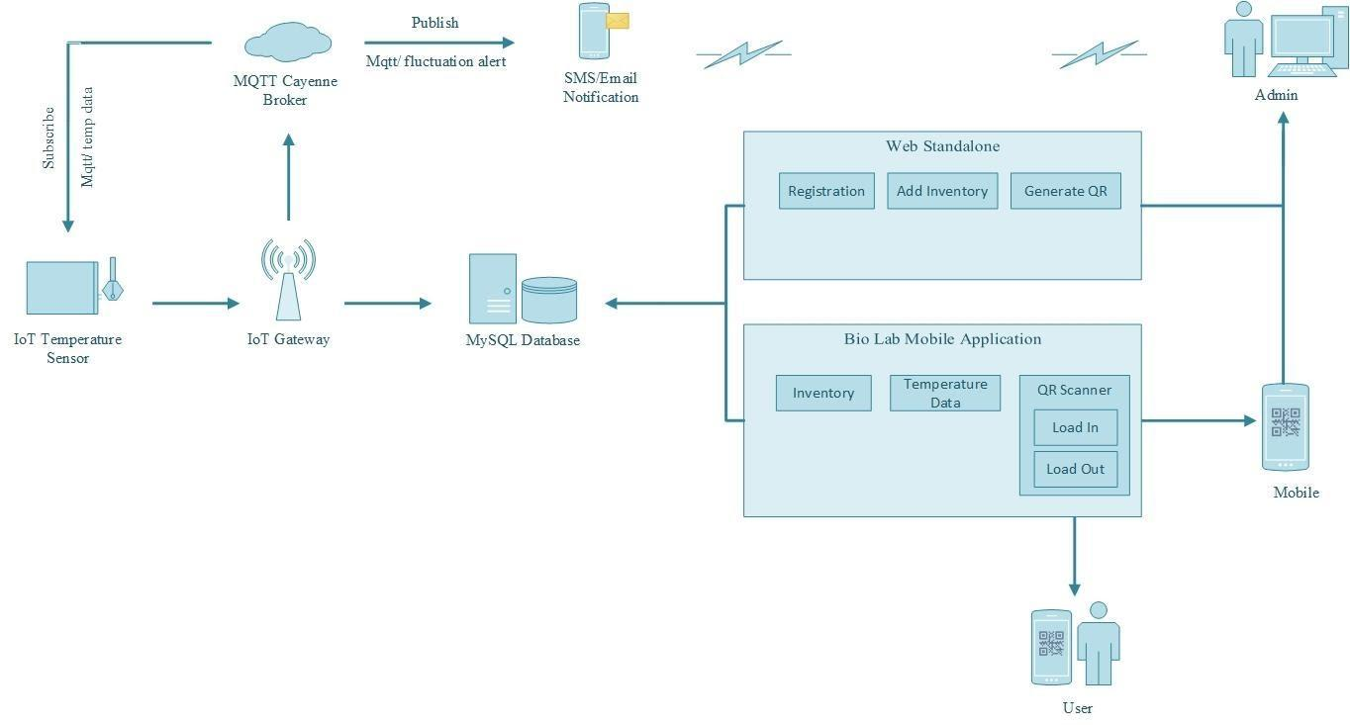

*Figure 2.* System Architecture

*Database Design*

The database design of the system illustrates the normalization of the tables used in the actual database of the system. Normalization is the process of organizing the data to minimize redundancy and to isolate data so that additions, deletions, and modifications of a field can be made in just one table and then propagated through the rest of the database via the defined relationships.

tblusers

|  |  |  |  |  |  |
| --- | --- | --- | --- | --- | --- |
| user  id | username | fname | mname | lname | contactno |
| 1 | admin | Stephen | Gabayeron | Sabinay | 09786547834 |
| 2 | ayuuhj | Ayrra Jane | Romualdez | Amio | 09876567812 |
| 3 | wongj | Jose Mari | Cabanilla | Wong | 09786543512 |
| 4 | xenonc | Mc Kelly | Doctora | Castro | 09876754315 |
| 5 | clarence.keith | Clarence Keith | Sabinay | Rebaya | 09785643451 |

|  |
| --- |
| userpass |
| 21232f297a57a5743894a0e4a801fc3 |
| 21232f297a57a5743894a0e4a801fc3 |
| 21232f297a57a5743894a0e4a801fc3 |
| 21232f297a57a5743894a0e4a801fc3 |
| 21232f297a57a5743894a0e4a801fc3 |

tblmaterials

|  |  |  |  |
| --- | --- | --- | --- |
| matID | dateentry | sampletype | souce |
| 1 | 2021-11-30 | RBC | Blood Sample |
| 2 | 2021-11-30 | Nails | N/A |
| 3 | 2021-11-30 | DNA | N/A |
| 4 | 2021-11-30 | Skin Cell | N/A |
| 5 | 2021-11-30 | Synovial Fluid | N/A |

|  |  |  |  |
| --- | --- | --- | --- |
| collector | location | userid | timelogged |
| ayuuhj | 2 | 1 | 2021-11-30 |
| ayuuj | 4 | 1 | 2021-11-30 |
| xenonc | 6 | 4 | 2021-11-30 |
| xenonc | 7 | 4 | 2021-11-30 |
| xenonc | 8 | 4 | 2021-11-30 |

tblinventorydata

|  |  |  |  |  |
| --- | --- | --- | --- | --- |
| inv | itemid | userid | desc | datetimelogged |
| 1 | 1 | 1 | in | 2021-11-30 20:09:21 |
| 2 | 2 | 1 | in | 2021-11-30 20:13:38 |
| 3 | 3 | 4 | in | 2021-11-30 20:14:30 |
| 4 | 4 | 4 | in | 2021-11-30 20:14:45 |
| 5 | 5 | 4 | in | 2021-11-30 20:15:18 |

tbltemperature

|  |  |  |
| --- | --- | --- |
| tmpid | temp | timelogged |
| 1 | 21.23 | 2021-11-13 |
| 2 | 22.50 | 2021-11-13 |
| 3 | 33.75 | 2021-11-13 |
| 4 | 33.50 | 2021-11-13 |
| 5 | 33.25 | 2021-11-13 |

tbl_location

|  |  |  |
| --- | --- | --- |
| locid | loc_name | val |
| 1 | A1 | 0 |
| 2 | A2 | 0 |
| 3 | A3 | 0 |
| 4 | A4 | 0 |
| 5 | A5 | 0 |

*Figure 3.* Database Tables of the System

*Procedural Design*

The procedural design explains the procedural details using any of the graphical or tabular design notations such as a structured flowchart. Illustration of the procedural details on how to operate the system and its processes used are illustrated.

As shown in figure 4, in the proposed standalone web system, the process will start when the admin creates an account for the users who will be using the Bio Lab mobile application. The admin will be the Laboratory Head and the users will be the Research Facilitators. The proposed web system will function solely for adding material inventory and for QR generation. To start, the admin must login. Next, the admin must input the needed information for the material. After that, the admin decides whether to add it to the inventory or not. Upon adding inventory, the system generates QR code for the admin to print.

As shown in figure 5, in the proposed mobile application, the admin or user must first login. The system will validate, and the admin can now select a process. Users can either view temperature data, inventory logs, scan QR to load in and out materials from the biofreezer.

As shown in figure 6, this figure shows the function of the QR Scanner. The admin scans QR on material vials to load item information and will select a process whether to load it in or out of the biofreezer. The admin can only load in what was loaded out of the biofreezer and can only load out what is currently inside the biofreezer.

As shown in figure 7, the temperature data, where the admin and users manage and view temperature data over time inside the biofreezer. The user can also generate reports that can be downloaded in csv file format.

As shown in figure 8, the inventory logs, where the admin and users manage and view inventory logs as well as generate log reports that can be downloaded in csv file format. A specific Item Inventory report can only be viewed and generated by the Laboratory head.

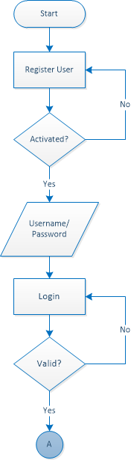

*Figure 4.* Flowchart of the proposed Standalone Web System for admin.

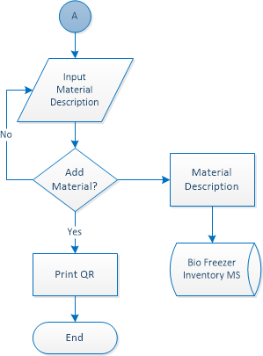

(Cont.)

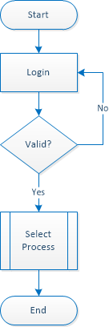

*Figure 5.* Flowchart of the Proposed Bio Lab Mobile Application

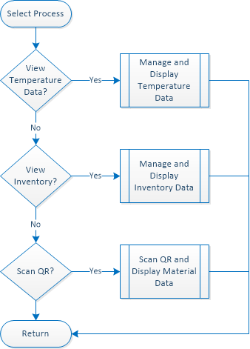

*(Cont.)*

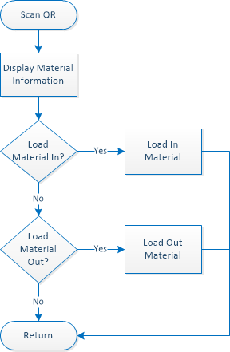

*Figure 6.* Flowchart of the QR Scanner

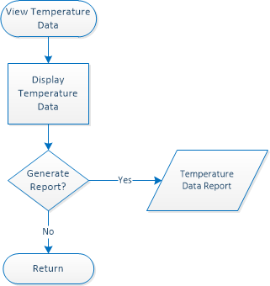

*Figure 7.* Flowchart of the Temperature Data

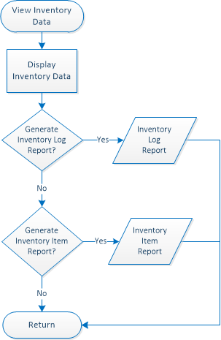

*Figure 8.* Flowchart of the Inventory Data

*Object Oriented Design*

The object-oriented design shows the relationship and interaction between the classes or objects created in the system. As shown in figure 10, the use case diagram specifies the externally visible system behavior from the admin and user perspective. The admin will be the Laboratory head while the users will be the Research Facilitators of the Biological and Physical Sciences Department of West Visayas State University. Both the admin and the user have access to the software and its functions along with the inventory and temperature data. Both can also generate and download reports of the inventory and temperature logs recorded but only the admin can add, edit, and delete item inventory as well as print the QR code needed for the material identification and create an account for a fellow admin or user.

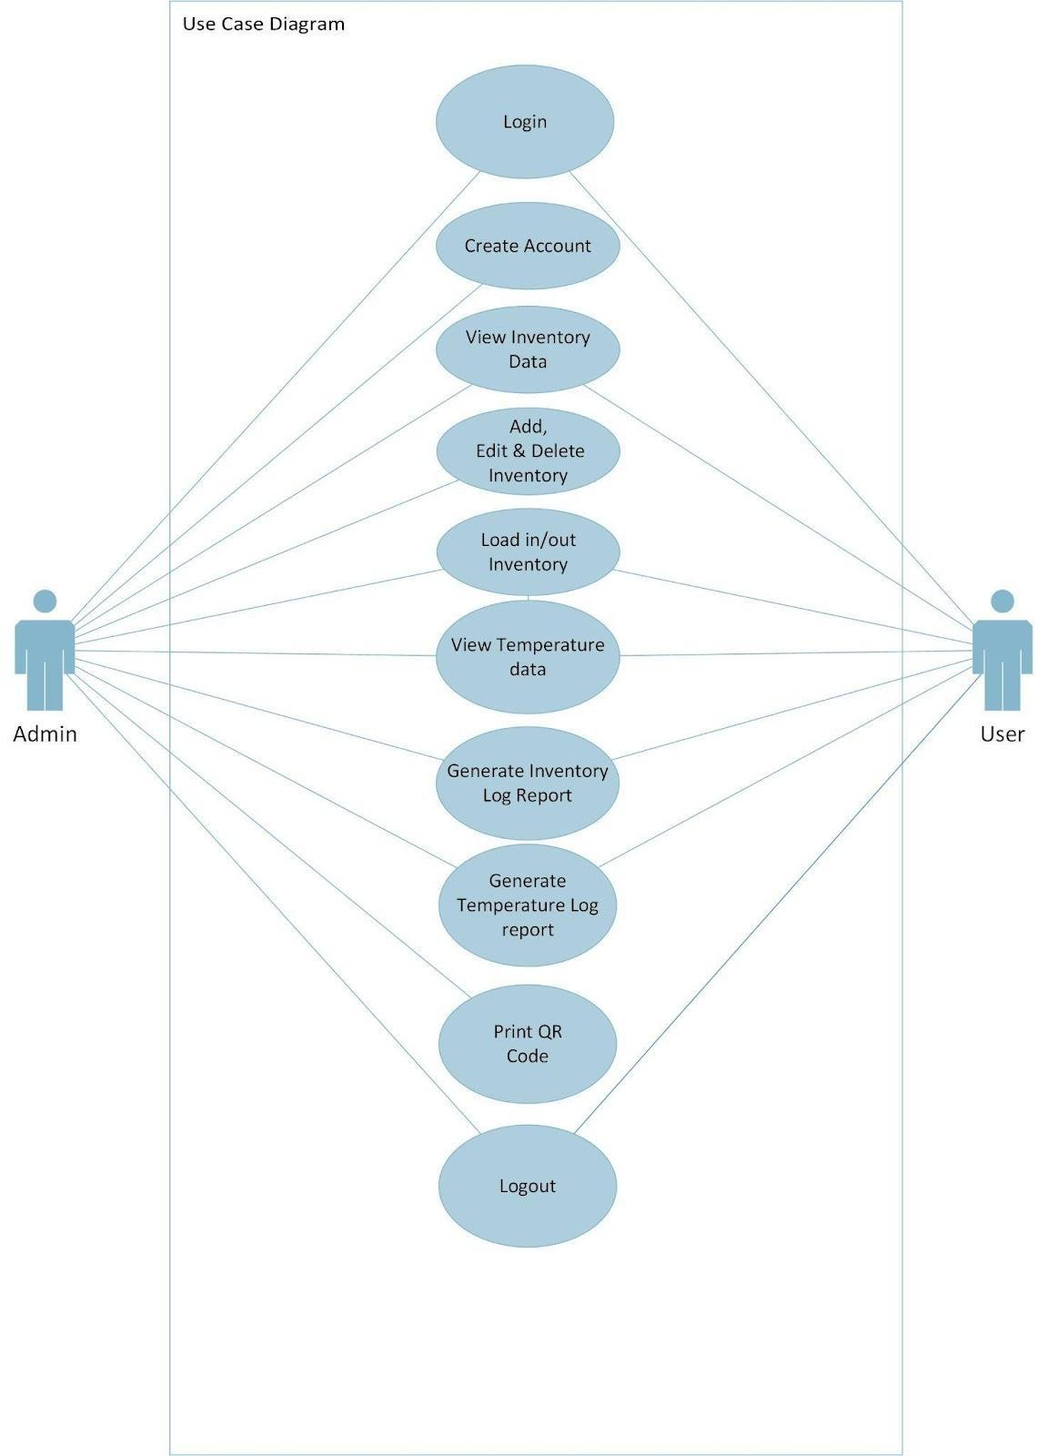

*Figure 9.* Use Case Diagram

*Process Design*

The process design maps out the flow of information in the system of the study.

As shown in figure 10, the flow of data is only accessible depending on the type of user that uses the system. The Laboratory Head may obtain the inventory logs, generated QR code, QR load in and out reports, temperature logs, description for biospecimen material and as well as QR load in and out. Furthermore, the Laboratory Head may input the biospecimen material description. On the other hand, the Research Facilitator may acquire the inventory logs, temperature logs, description for biospecimen material and QR load in and out. Both users may input their username and password and the Laboratory Head is required to create not only his/her own account but also that of the Research Facilitator.

As shown in figure 11, the level 1 web diagram shows the specified flow of data that is accessible to the Laboratory Head. The Laboratory Head may register his/her data as well as that of the Research Facilitator using the username and password, user type and contact information and encode the biospecimen material description to the system. Moreover, the Laboratory Head may secure the inventory logs, generated QR code, QR load in and out reports, temperature logs, description for biospecimen material and as well as QR load in and out.

As shown in figure 12, the level 1 mobile diagram specified flow of data that is accessible to both the Research Facilitator and Laboratory Head. The Research Facilitator may login his/her username and password to use the mobile applications feature as well as may utilize QR load out/load in, biospecimen material description, temperature logs, and inventory logs.

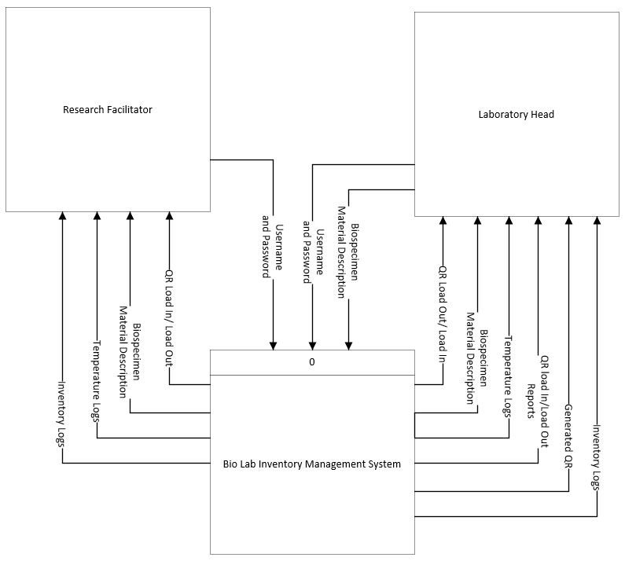

*Figure 10.* Context Diagram of the System

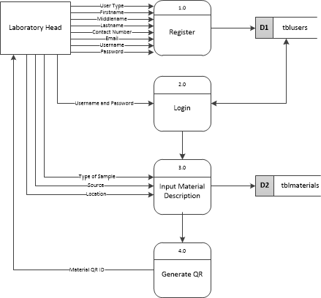

*Figure 11.* Level 1 Bio Lab Standalone Web System

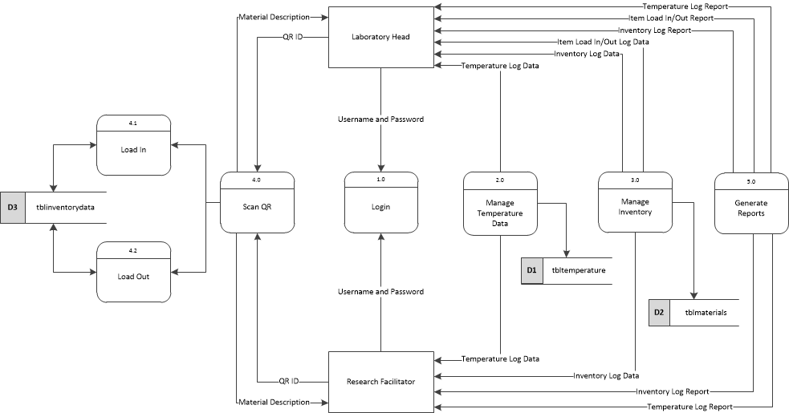

*Figure 12.* Level 1 Bio Lab Mobile Application

*System Development Life Cycle*

This study adopts the Scrum agile method where new features are developed incrementally in short sprints. At the end of each Sprint, a potentially usable Increment of product can be made available. This helps the researchers to potentially release a much earlier version of the product in the development cycle enabling benefits and risk to be realized earlier than otherwise may have been possible if the researchers waited for the entire product to be "complete" or fully finished before a release. As shown in figure 16, the Agile-Scrum Method was composed of the following stages:

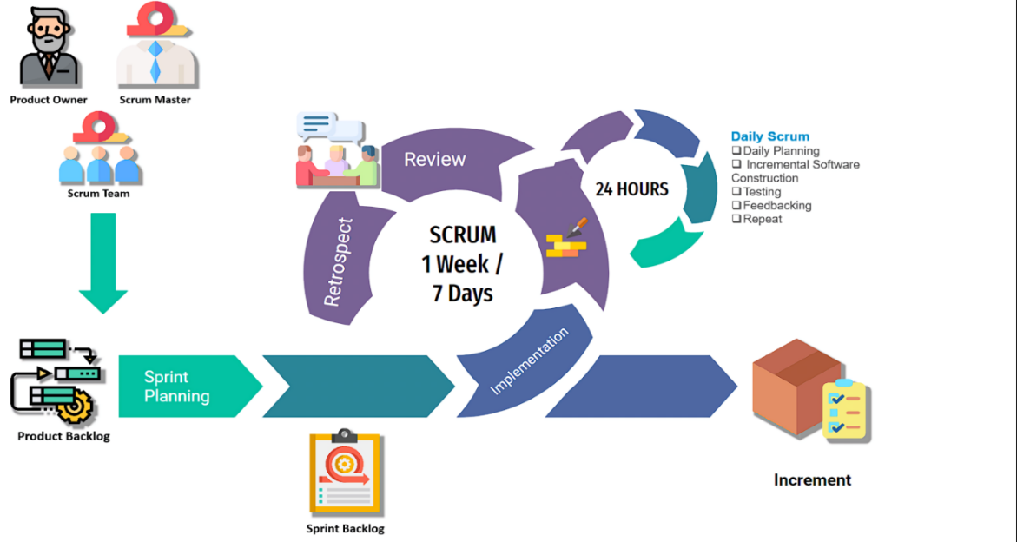

*Figure 13. Scrum Agile Method*

Maintaining quality is a key principle of development with Scrum. Testing occurs every Sprint, enabling regular inspection of the working product as it develops. This allows the Scrum Team early visibility of any problems and allows them to adjust where necessary. This method encourages active Product Owner or client involvement throughout the development of this study. Transparency is therefore much higher, both around progress and of the state of the product itself, which in turn helps to ensure that expectations are effectively managed. Other benefits the researchers can get from this method are flexibility, Cost control, Customer satisfaction, and speed to market.

*Product Backlog Creation*. The Product Owner, scrum master, and scrum team meet to create the final vision of the project. Therefore, a product backlog is created with the full list of features, functions, and requirements needed to build the full final product. For the product backlog of this study the client being the Assistant Professor and Head of Center for Biotechnology and Biomedical Research, admin designation of West Visayas State University, aims to have a system that can both monitor real-time temperature and notify the user via SMS during temperature fluctuation for Ultra-low Biofreezers and has a QR Code-integrated software application that detects the QR code for the biospecimens. The software application can store and record data logs and can generate a daily record of fluctuations and manifesto reports. All project vision was taken note of by the scrum master and the scrum team and was able to create a list of features, functions, and requirements needed for the study.

*The Product Backlog.* The scrum team with the guidance of their adviser came up with an initial system design that utilizes a "Node MCU ESP8266", a "K-Type Thermocouple" with the "MAX6675 module" which is a sophisticated thermocouple to digital converter with a built-in 12-bit analog-to-digital converter, a "Node MCU Baseboard", and a "12c LCD Adapter", all of these composes the Hardware device and is connected to a "MySQL" which is a database management system where the client can use functions such as "add", "delete", and "edit" inventory list and lastly an android application that will output the inventory and temperature data and will have a feature that scan QR codes and can notify the user via SMS.

*Sprint Planning and Sprint Backlog Creation.* After meeting with the client, the scrum master again meets with the scrum team to discuss, schedule, prepare and plan for the first sprint therefore a sprint planning or a sprint meeting was commenced and sprint backlog is therefore created, within the sprint backlog contains a subset of requirements taken from the product backlog which were chosen and set to priority to be done first.

*Sprint Backlog.* The scrum master and the scrum team decided to prioritize the construction of the given hardware components mainly to integrate the NodeMCU ESP8266, the MAX6675, and the 12c LCD Display. The building of the subset requirements indicated in the scrum team's sprint log commences. Within the duration of the sprint, there are daily scrums composed of Incremental hardware components and software code construction.

*Testing and Product Demonstration.* At the end of each iteration, the scrum master scrum team will hold a meeting to review potential product deliverables. The team then reviewed and continued to improve the incremented final product.

*Retrospective and The Next Sprint Planning*. After the review meeting, the scrum master again meets with the scrum team to discuss, schedule, prepare and plan for the second sprint therefore a second sprint planning or a sprint meeting was commence and another sprint backlog is therefore created, within the sprint backlog contains a new subset of requirements taken from the product backlog which were chosen to be done and the whole sprint begins again with daily scrums ending with an increment of the final product and a sprint retrospective review.

CHAPTER 4 RESULTS AND DISCUSSION

Implementation

The whole system which includes both the IOT temperature monitoring device, and the inventory management system was tested several times to ensure its reliability.

The system was set in the laboratory of the Biological and Physical Sciences Department of West Visayas State University. The researchers were assisted by the Head and the respected staff of the Biological and Physical Sciences Department of the said University.

For the testing, the researchers required any cold storage container whose temperature ranges from 15℃ to 0℃, where the temperature measuring device was attached as well as a digital thermometer for comparison purposes. It was where the system acquired the temperature inside the freezer and was processed as input. For the arranged tests, the researchers’ goal is to present the basic functionality of the IOT temperature monitoring device for proof of concept, which was to detect temperature readings of cold storage containers.

For the installation of the IoT Device, the extending thermocouple probe from the device was inserted inside the provided storage container, in the researcher’s case would be the laboratory’s Incubator with a built-in temperature probe for comparable temperature readings. Outside the said incubator, the device was attached via a wall mount or placed nearby the container and is plugged to an accessible power source 220w socket using a 9v AC adapter.

For the installation of the Inventory Management System, the researchers required a computer or laptop where it acted as the localhost of the system. A browser of choice was installed in the computer to run the standalone web application. Moreover, the mobile application version was installed in an Android Smartphone. Admins’ phone number and email address will be provided for testing the user notification features.

System Inputs and Outputs

The inputs and outputs of the application are fully described below. To start, Figure 14 shows the IoT device thermocouple probe installed on a cold storage for temperature monitoring.

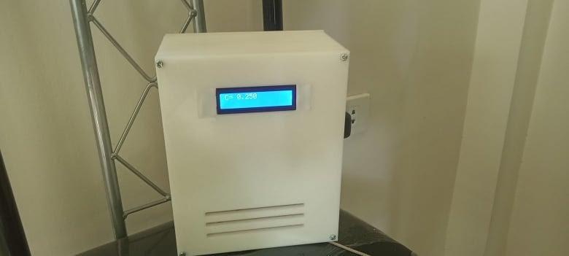

*Figure 14.* IoT Device thermocouple probe

Figure 15 shows the web login page for the admin where they can either login or register an account for co-admins or users.

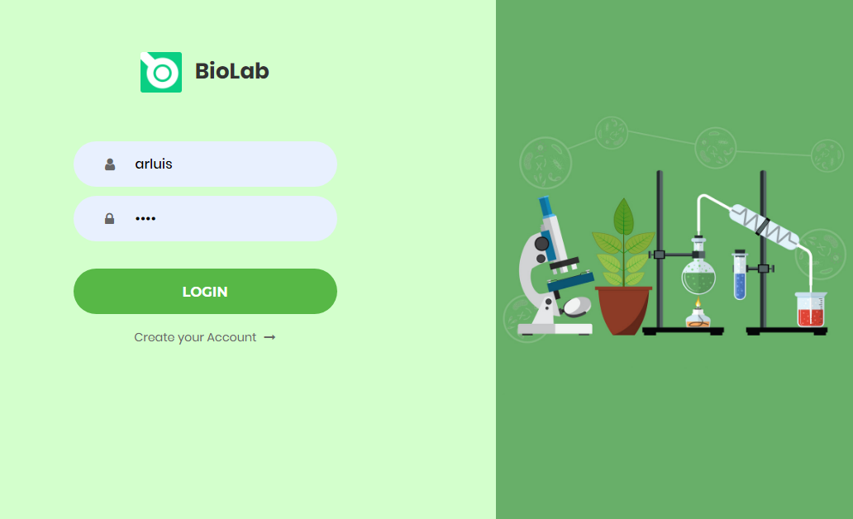

*Figure 15.* Web Login Page

Figure 16 shows the web registration page where admin registers an account for fellow admins or users.

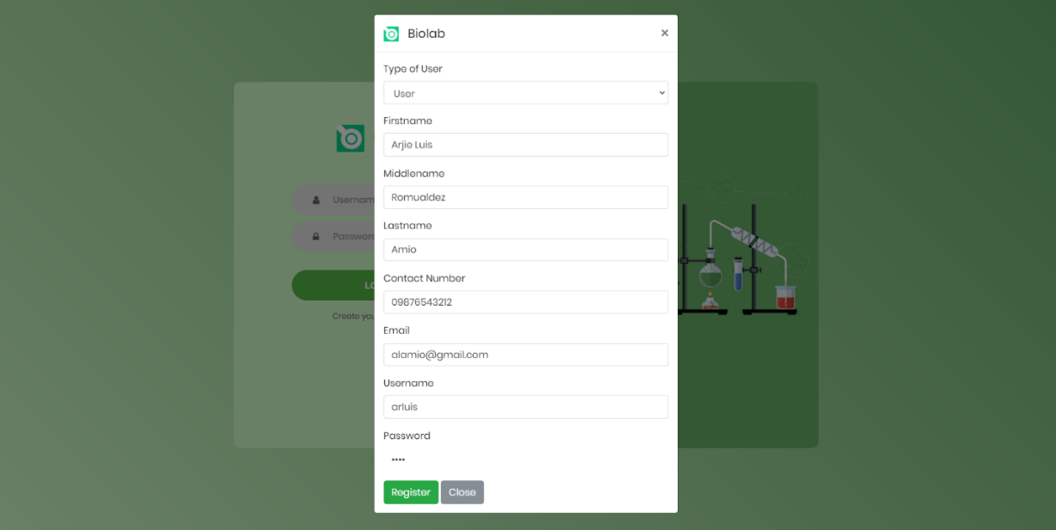

*Figure 16.* Web Registration Page

Figure 17 shows the mobile application login page for the admin and users where they can login to the Bio Lab.

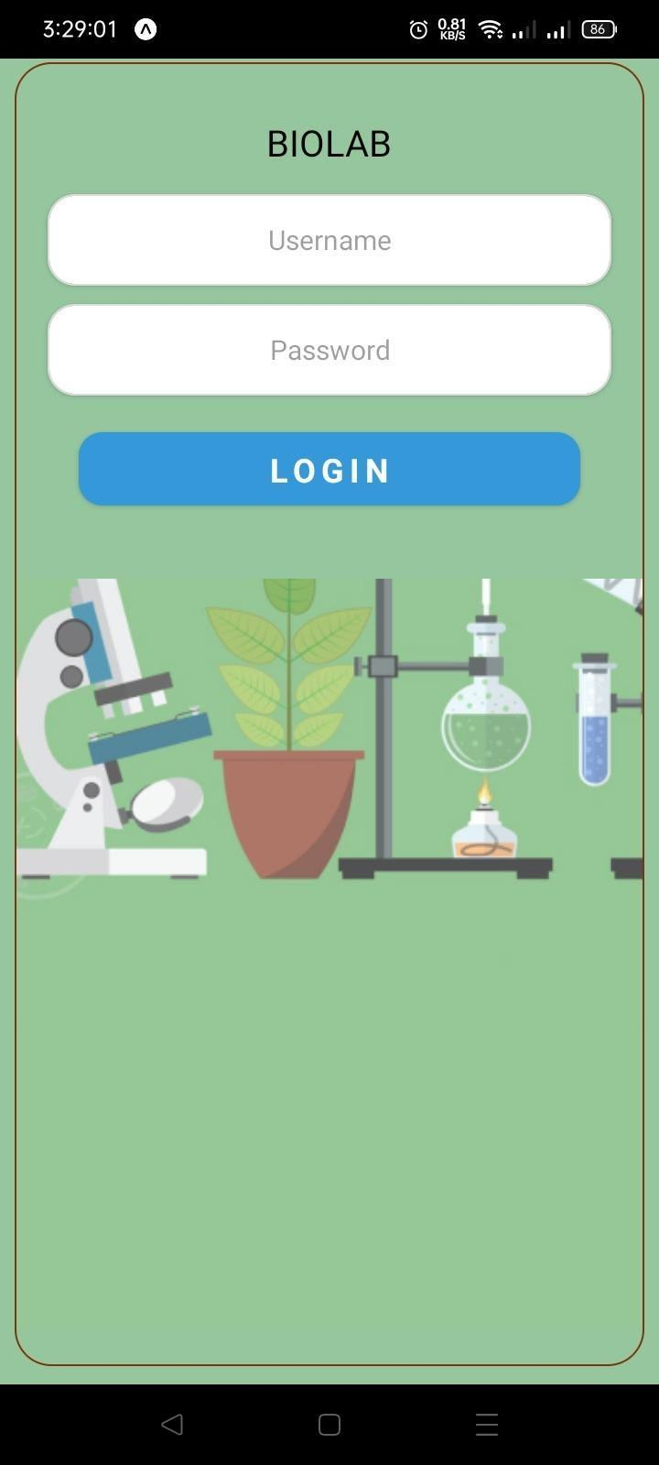

*Figure 17.* Mobile Application Login Page

Figure 18 shows the web standalone adding of an item inventory for the admin. The admin must input the material description needed for inventory.

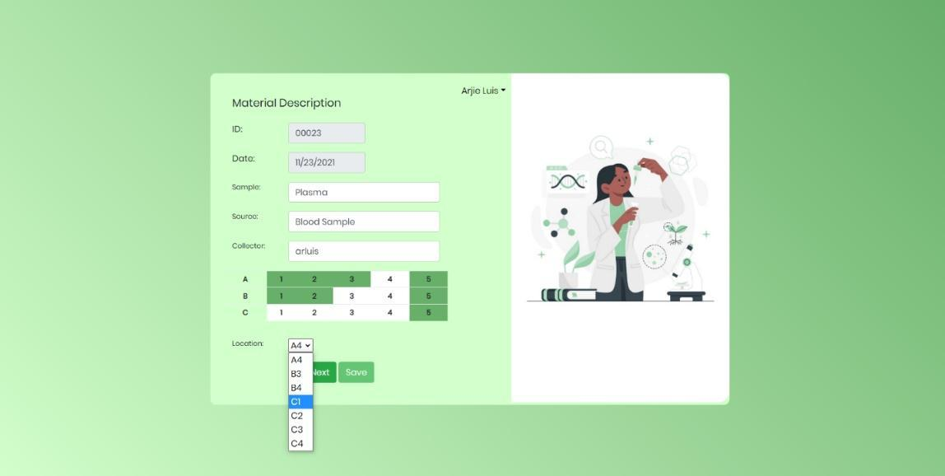

*Figure 18.* Web Add Item Inventory Page

Figure 19 shows the adding of inventory, QR code shows up for the admin to print on a recommended sticker paper and to be put on vials for inventory.

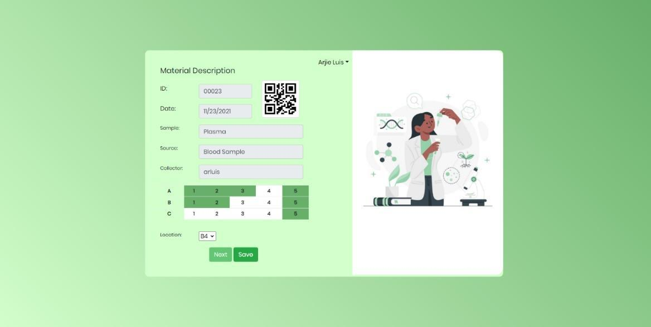

*Figure 19*. Web QR Generation

Figure 20 shows the mobile application QR scanner part where the admin and user can Load In and Out materials inside the biofreezer.

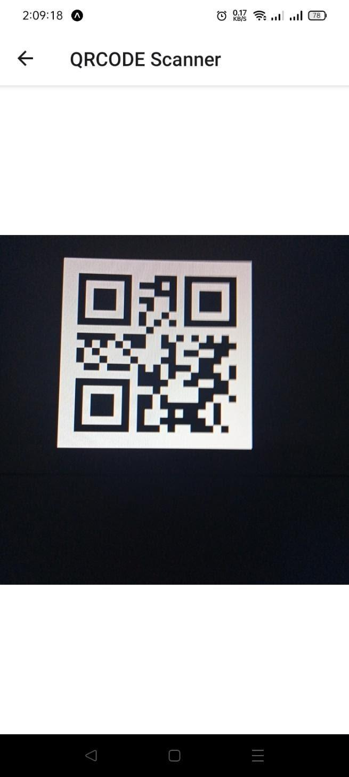 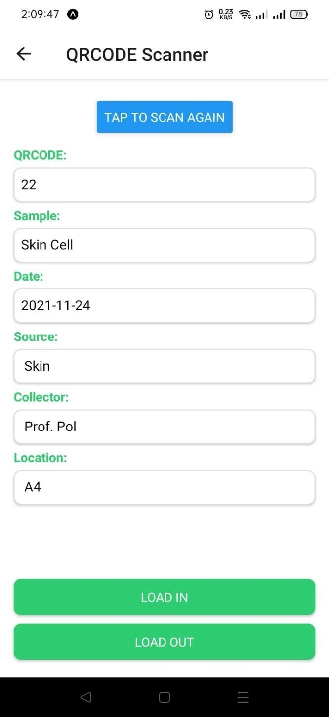

*Figure 20.* Mobile Application QR Scanner

Figure 21 shows the main menu of the mobile application. This page is where the admin and user have an option to view inventory, temperature data or use the QR scanner.

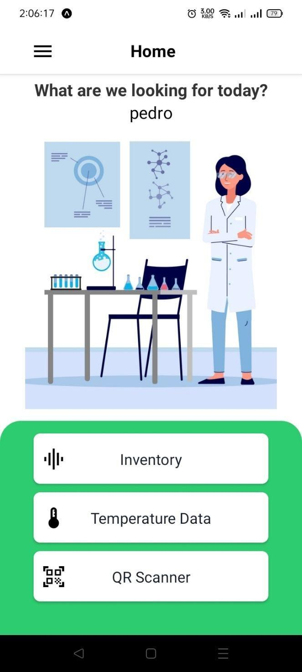

*Figure 21.* Mobile Application Main Menu Page

Figure 22 shows the mobile application Inventory Page where admin and user can see a list of inventory logs.

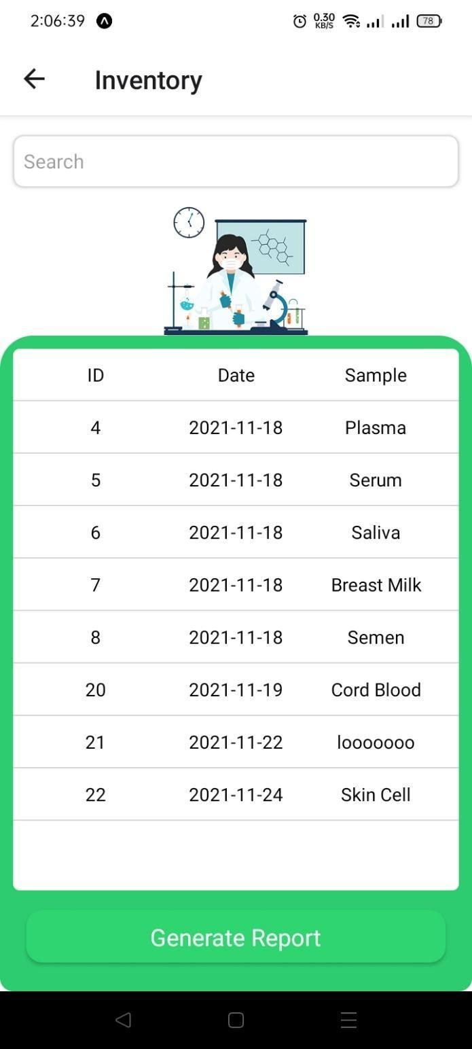

*Figure 22.* Mobile Application Inventory Page

Figure 23 shows the mobile application Temperature Data Page where admin and user can see temperature logs during a specific date and time.

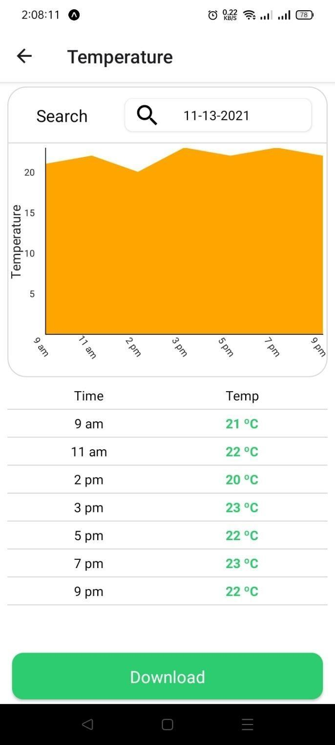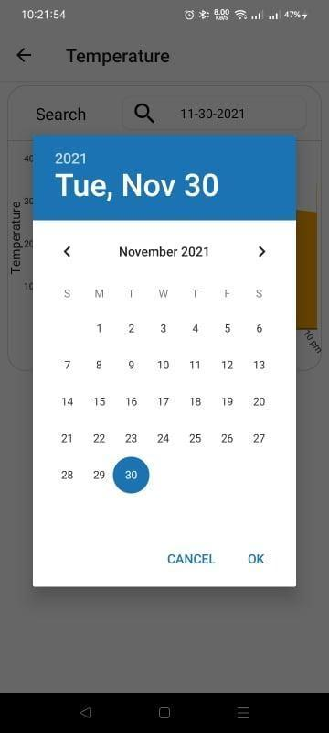

*Figure 23*. Mobile Application Temperature Data Page

Figure 24, 25, and 26 shows the downloadable reports that are generated through the mobile application which include the inventory, Item Load In and out and the temperature data log reports. The downloadable reports will be in csv format.

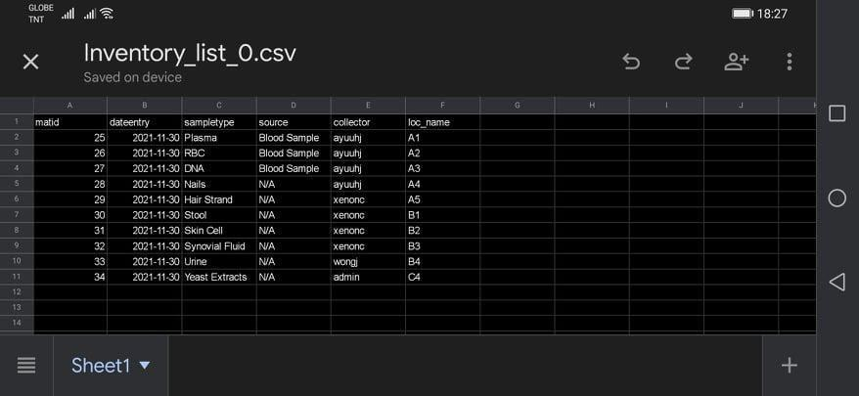

*Figure 24.* Inventory Log Report

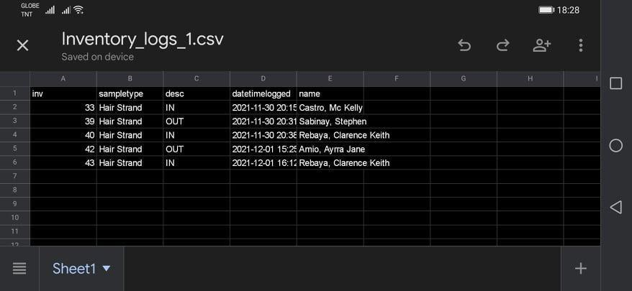

*Figure 25.* Inventory Item Load in and out Report

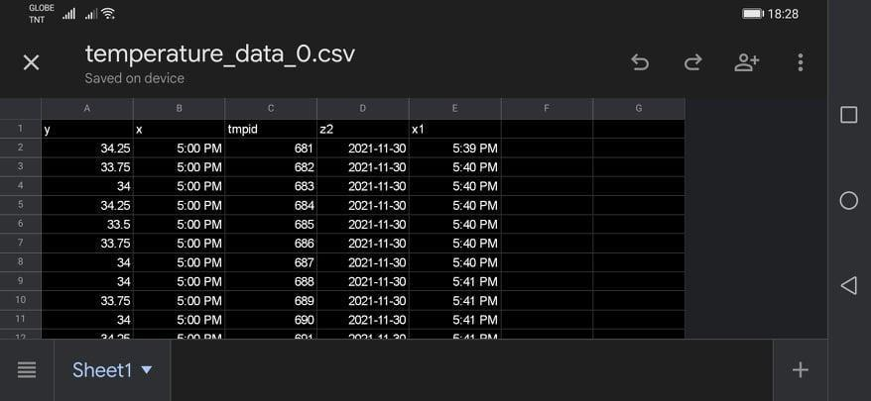

*Figure 26.* Temperature Data Log Report

*Simulation Environment and Scenarios*

The first simulation process started when the researchers opened the standalone web application for the creation of either an admin or a user account. The researchers then added an inventory item then prints the QR code generated and labeled it to the vial of the desired specimen or sample for storage. The researchers opened the mobile application and logged in with the registered admin account. Now, the researchers had access to the inventory logs, inventory item load ins and outs, and the temperature data. The admin account could edit and delete inventory data and can also generate reports by downloading a generated csv file. The researchers could also go to the QR scanner portion for scanning to view certain sample descriptions and has the option to load it in or out if it has been "loaded in" or "loaded out".

The researcher then logged as a user, to test what features the user could access. Same with the admin account, the user account could also see the inventory, temperature data and could use the "QR scanner" built with-in the mobile application and could generate reports. The only thing the user could not access is the load in and out inventory logs.

To assess the functionality of the IoT device, the device was installed inside a consumer grade refrigerator whose temperatures ranged from 0c to 15c in-order to measure the reliability and consistency of the temperature readings. The thermal probe was inserted inside the refrigerator’s chiller and was left inside for one hour. The device was set to get temperatures with a 10 second interval.

For the second simulation, a consumer grade icebox was prepared and then filled with ice. A digital thermometer is then inserted inside together with a thermocouple probe for comparison. The built cold storage container was then enclosed or sealed properly in-order to make sure proper simulation temperatures were generated.

To assess the functionality of the notification alert, the researchers manipulated environmental variables that caused the observed temperature readings to fluctuate inside the storage container such as opening the storage and exposing it to the outside temperature and by exposing the probe to a lighted candle. The manipulation of the temperature triggered an Email and SMS alert notifying to the user that the current parameter or threshold that had been set has been reached. For simulation purposes the researcher had set the limit to 38.5c, any temperature beyond that will cause a trigger event. The MQTT then sent E-mail and SMS alerts to the user.

*Results Interpretation and Analysis*

The device was tested on a commercial grade refrigerator and was left for 1 hour. The researchers had inserted the thermocouple through the door and had it sealed completely in order to observe and avoid any unnecessary sudden fluctuation in the temperature inside the refrigerator.

For 10 minutes the researcher had observed that the device was reading a temperature at around 7 to 9 degrees Celsius as indicated by the device's onboard LCD screen. By the 30-minute mark the temperature reading stayed constantly at around 9 degrees Celsius. After 50 minutes had passed, the researchers then removed the thermocouple inside the refrigerator and exposed it to room temperature which resulted a gradual increase in the temperature. By the 55-minute mark the researcher then tested the notification function of the device by exposing the thermocouple next to a cigarette lighter until the temperature had reached the set threshold.

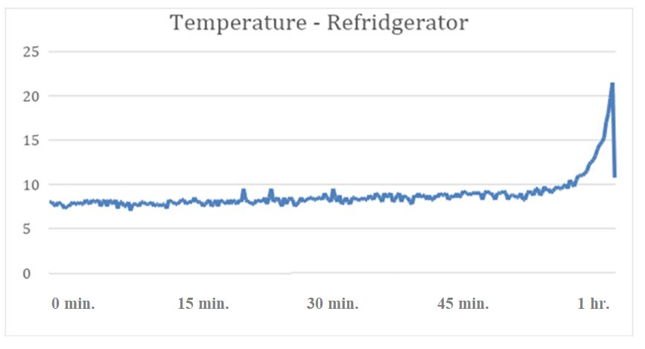

*Table 1*. Temperature over time inside the consumer grade refrigerator

Figure 27 shows the sample screenshot of the Email and SMS alert sent every time by the Cayenne MQTT Service to the user when the device reads a fluctuation of temperature inside the consumer grade refrigerator.

The fluctuation was controlled by the researchers by setting a threshold value of 38.5 degrees Celsius in the Cayenne MQTT Service and by purposely heating the tip of the probe to increase the temperature. When the reading exceeded 38.5 degrees Celsius, the Cayenne service automatically notified a predetermined group of users via email and text message alerts.

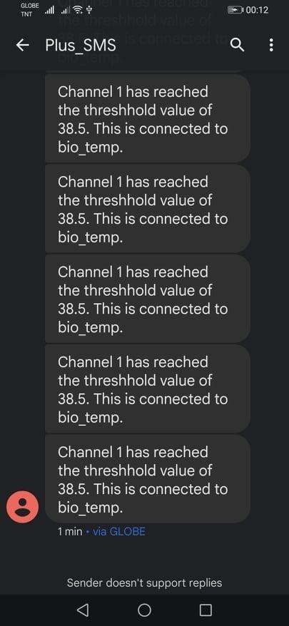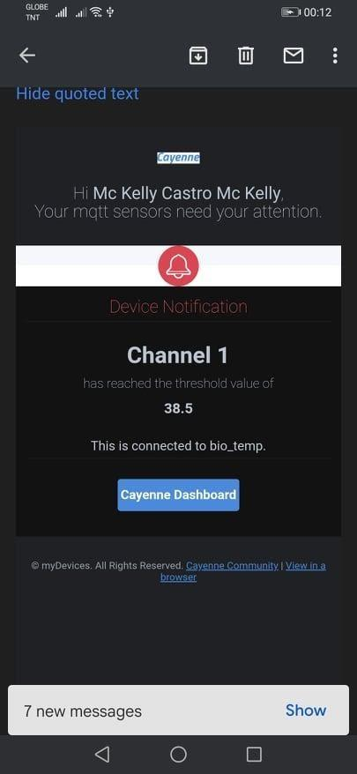

*Figure 27.* User Notification through SMS and Email by the Cayenne MQTT Service

System Evaluation Results

The results were evaluated by getting the mean of results for each category. A scale system, seen in Table 2, was used to rate the application’s performance in certain areas. Five (5) for Excellent, Four (4) for Very Satisfactory, Three (3) for Satisfactory, Two (2) for Fair, and One (1) for poor.

|  |  |
| --- | --- |
| **Scale** | **Description** |
| 5.00 - 5.99 | Excellent |
| 4.00 – 4.99 | Very Satisfactory |
| 3.00 – 3.99 | Satisfactory |
| 2.00 – 2.99 | Fair |
| 1.00 – 1.99 | Poor |

*Table 2.* Mean Scale System

To evaluate the application, only the “product owner” which was the laboratory head of the Biological and Physical Sciences Department was chosen. The evaluation form used was based on the ISO/IEC 25010 Standard Software Evaluation Questionnaire. As shown in table 3, the results of the user evaluation were performed.

The results mostly showed the application having performed *“Very Satisfactory”* and *“Excellent”* in one area. Based on the results of the user evaluation, the device’s temperature measurements were accurate, having scored a mean of 4.8, which means that it scored 96% in the System evaluation report by the product owner. The device scored the highest with a score of a 5.0, marked as ‘Excellent’, in 5 different areas such as (1) Functionality and Suitability, (2) Compatibility, (3) Usability, (4) Maintainability and (5) Portability for having accomplished its basic functions and the studies’ objectives. For the performance area it scored a 4.7, marked as ‘Very Satisfactory’. Scoring the lowest is the reliability criteria. This means that the product owner found the application and its hardware not that reliable in terms of monitoring temperature and that can be further refined and improved. For the application the user experience can be further polished by enhancing its aesthetics. For the hardware, the device can be built on a smaller platform reducing size and weight though it scores a perfect 5 in the portability area; these suggested improvements are geared towards better reliability and security of the components inside and for the device itself.

Overall, the result of the evaluation for the system was *“Very Satisfactory”*, meaning, the application was found by the product owner to be useful, easy to use and responsive.

|  |  |  |
| --- | --- | --- |
| Criteria | Mean | Description |
| Functional Suitability | 5 | Excellent |
| Performance Efficiency | 4.7 | Very Satisfactory |
| Compatibility | 5 | Excellent |
| Usability | 5 | Excellent |
| Reliability | 4 | Very Satisfactory |
| Security | 4.8 | Very Satisfactory |
| Maintainability | 5 | Excellent |
| Portability | 5 | Excellent |
| Overall Evaluation | 4.8 | Very Satisfactory |

*Table 3.* Evaluation Results for the Proposed System

*Jurors’ Suggestion for Improvement*

During the evaluation and consultation, the expert consultant/product owner and adviser suggested that the system can also be implemented to not only Ultra-low Biofreezers but also Biomedical freezers, cold storages, and Incubators. The system should also instead use a line graph in showcasing temperature data over time for better readings and analysis. The system should store data on the cloud for easy storage and accessibility, better security, and fault tolerance.

In the standalone web system, the graphic container for choosing a location should present the exact locations inside the biofreezer.

CHAPTER 5 SUMMARY, CONCLUSIONS, AND RECOMMENDATIONS

Summary of the Proposed Study Design and Implementation

The Bio Lab Inventory Management System is an android mobile application designed for the Biological and Physical Sciences Department Laboratory Head and Faculty Researchers of West Visayas State University to aid their current system in the department as well as manage inventory inside biofreezers using QR-code technology. Not only that, but the system also provides temperature data from the developed IoT Device sensor. The said sensor is installed inside the storage and is also inserting data to an MQTT service broker, Cayenne, for the purpose of sending user notification via SMS and email in case of temperature fluctuations.

The Bio Lab IMS is very useful to laboratory researchers since it is portable given that it is a mobile application. If it is implemented, it will be easier to monitor data inside storages and generate reports.

Summary of Findings

The system is still subject to improvements that will further enhance its capabilities in the future. It is very object-oriented and can be integrated and upgraded as needed.

The IoT inventory management system uses QR code technology for managing biospecimen materials inside the biofreezer. This also includes a web standalone for the purpose of generating QR codes and adding item inventory. Not only that, but the system also provides temperature data from the developed IoT Device sensor. The sensor is also inserting data to an MQTT service broker, Cayenne, for the purpose of sending user notification via SMS and email in case of temperature fluctuations.

The system is portable which greatly helps users manage materials and monitor temperature inside the biofreezer regardless of its location. Inventory and temperature data are now automated and secured which can be used to show efficiency in the department’s monitoring process for compliance of a good laboratory practice.

In testing the application, the product owner was given the evaluation form based on the ISO/IEC 25010 Standard Software Evaluation Tool. After navigating through the application, the results were examined and showed a very satisfactory rating from the target user of the application.

The researchers conclude that the Biological and Physical Sciences Department should use this system to assist laboratory personnel in managing biospecimens and monitoring temperature inside biofreezers. They also need to have a server that can hold the inventory and temperature data. This system is well-designed and is easy to use. It cannot only be used in the Biological and Physical Science Department but also in other laboratories that use similar equipment.

Conclusions

Using Ultra-low Biofreezer is one of the most important tools used in the laboratory. The biofreezer protects the biological sample by keeping it at a very low temperature. The failure of it not only results in significant financial loss, but can also endanger samples that disrupt critical research. With the increasing number of biospecimens being stored and monitored inside cold equipment, especially in the field of medical education, there will be a need for a systematic way to manage its storage. The researchers proposed to develop a functional IoT inventory management system for the Biological and Physical Sciences Laboratory of West Visayas State University, to manage the biospecimens in Ultra-low Biofreezers. The developed application was able to give the product owner the features of temperature monitoring, user notification and management of inventory based on QR technology.

The researchers therefore concluded that the system had successfully accomplished the set objectives that were specified in the first phase of the study namely:

1. The system is a Biospecimens Inventory Management Mobile Application integrated with QR code technology for an inventory of biospecimens inside Ultra-Low Biofreezers and real time temperature monitoring.
2. The system has an IoT device using ESP8266 NodeMCU that can continuously send temperature data to Biospecimens Inventory Management Mobile Application.
3. The system integrated a user notification using Cayenne MQTT Framework and SMS Technology for user notification in the event of sudden temperature fluctuations in Ultra-low Biofreezers.
4. The system was implemented, tested, and evaluated based on usability and effectiveness using the ISO/IEC 25010:2011 Systems and Software Quality Requirements.

Furthermore, the researchers were able to implement a standalone web system recommended in the application. The standalone web system was further developed solely for the purpose of a convenient adding of item inventory and the generation of QR codes for printing. The user evaluation results overall showed a “Very Satisfactory” rating from the product owner. It can therefore be inferred that the product owner is enthusiastic and interested in using IoT for the temperature monitoring and Inventory system based on emerging technology to manage biospecimens in ultra-low biofreezers.

Recommendations

To further improve the efficiency and effectiveness of the system, the researchers recommend the following:

1. The system can add features like the temperature readings can go below -0c which then can be used effectively in Ultra-low Biofreezer.
2. The researchers would like to recommend asking for help and guidance of electronic engineering professionals for the development of the IoT device.
3. For temperature readings, a line chart should instead be used in showcasing temperature data over time for better readings and analyses.
4. For the standalone web system, the graphic container for choosing a location for an item should present exactly at the same location inside the biofreezer.
5. The inventory system should be cloud-based so that it would not be limited to the localhost only, and so it can be accessed anywhere in any network. Also, this helps improve security and fault tolerance.

References

Arduino Integrated Development Environment (IDE). (2021). Arduino Software (IDE). Retrieved November 27, 2021, from <https://docs.arduino.cc/software/ide-v1/tutoria>ls/arduino-ide-v1-basics.

Components 101. (2021). NodeMCU ESP8266*.* Retrieved

November 27, 2021, from <https://components101.com/>

development-boards/nodemcu-esp8266-pinout-features-and-datasheet.

Del C, A. S. (2021). Cayenne MQTT API. *GitHub.* Retrieved November 27, 2021, from [https://github.com/ myDevicesIoT/cayennedocs/blob/master/docs/MQTTAPIS.md](https://github.com/%20myDevicesIoT/cayennedocs/blob/master/docs/MQTTAPIS.md).

Digite Inc. (2022). Scrum Methodology & Scrum Project Management. Retrieved February 22, 2022, from https://www.digite.com/agile/scrum-methodology/.

FactoryForwardIndia. (2021). ESP8266 NodeMCU CH340 Base Board I/O Expansion Board*. FactoryForwardIndia.* FactoryForward India Microcontroller Board Distributor & Store. Retrieved November 27, 2021, from https://www.factoryforward.com/product/esp8266nodemcu-base-board-i-o-expansion-board/.

Froilabo. (2021). Ultra-Low Temperature Freezers, Chest & Upright Lab Freezer, -86OC*.* Retrieved November 27, 2021, from <https://www.froilabo.com/types/ultra-low->temperature-freezers/.

Hayes, A. (2021, March 29). Quick Response (QR) Code. *Investopedia.* Retrieved January 7, 2022, from https://www.investopedia.com/terms/q/quick-response-qr-code.asp.

Kurniawan, D. E., Iqbal, M., Friadi, J., Borman, R. I., & Rinaldi, R. (2019, November). Smart monitoring temperature and humidity of the room server using raspberry pi and whatsapp notifications*.* In Journal of Physics: Conference Series (Vol. 1351, No. 1, p. 012006). IOP Publishing. Retrieved last November 25, 2021, from [https://iopscience.iop.org/article/10.1088/ 1742](https://iopscience.iop.org/article/10.1088/1742)-6596/1351/1/012006.

LastMinuteEngineers.com. (2020). Interface an I2C LCD with Arduino*.* *Last Minute Engineers*. Retrieved November 27, 2021, from https://lastminuteengineers.com/i2c-lcd-arduino-tutorial/.

Maxim Integrated. (2021). Cold-Junction Compensated Thermocouple-to-Digital Converter*.* Retrieved November 27, 2021, from <https://www.maximintegrated.com> /en/products/interface/sensor interface/MAX31855.html.

Merriam-Webster. (n.d.). Notification. in Merriam-Webster.com dictionary. Retrieved November 27, 2021, from <https://www.merriamwebster.com/> dictionary/ notification.

Omega Engineering Inc. (2020). What is a type K Thermocouple? *Omega Engineering Incorporated*. Retrieved November 25, 2021, from [https://www. omega.com/en-us/resources/k-type-](https://www.omega.com/en-us/resources/k-type-)thermocouples.

Khotimah, K., Sudrajat, M. I., & Wahyu Hidayat, S. (2019). Infant Incubator Temperature Controlling and Monitoring System by Mobile Phone Based on Arduino. 2019 International Seminar on Research of Information Technology and Intelligent Systems (ISRITI). Retrieved November 25, 2021, from <https://doi.org/10.1109/> isriti48646.2019.9034646.

Powell, S., Molinolo, A., Masmila, E., & Kaushal, S. (2019). Real-time temperature mapping in ultra-low freezers as a standard quality assessment. Bio preservation and Biobanking, 17(2), 139-142. Retrieved February 6, 2021, from [https://doi.org/10.1089/ bio.2018.0108](https://doi.org/10.1089/bio.2018.0108).

Shukran, M. A. M., Ishak, M. S., & Abdullah, M. N. (2017). Enhancing Chemical Inventory Management in Laboratory through a Mobile-Based QR Code Tag. IOP Conference Series: Materials Science and Engineering, 226, 012093. Retrieved February 6, 2021, from https://doi.org/10.1088/1757-899x/226/1/012093.

SiteGround Hosting Ltd. (2021). What is SQL and MySQL? Retrieved November 27, 2021, from https://www.site

ground.com/tutorials/php-mysql/mysql/.

Spofford, D. (2019, July 19). What is MQTT in IoT? *Very*. Retrieved last November 27, 2021, from https://www. verypossible.com/insights/what-is-mqtt-in-iot.

University of California. (2021). What are Human Biospecimens? Biospecimen Resource Program. Retrieved November 27, 2021, from https://bios.ucsf.edu/what-are-human-biospecimens.

APPENDICES

Appendix A

Letter to the Adviser

March 2, 2021

**DR. EVANS B. SANSOLIS**

Instructor I

College of Information and Communications Technology

West Visayas State University – Main Campus

Luna Street, La Paz, Iloilo City

Dear Dr. Sansolis,

The undersigned are BSIT 4th year students of CICT in this university. Our thesis/capstone project title is **“Internet-of-Things Inventory Management System for Ultra-low Biofreezer in MQTT Framework”**.

Knowing your expertise in research and on technology, we would like to request you to be our **THESIS ADVISER.**

We are positively hoping for your acceptance. Kindly check the corresponding box and affix your signature on the space provided. Thank you very much.

Respectfully yours,

1. Amio, Ayrra Jane R.

2. Castro, Mc Kelly D.

3. Sevilla, Winston C.

4. Soncio, Paul Adrian D.

5. Wong, Jose Mari C.

PS:

*Advisers are tasked to work with the students in providing direction and assistance as needed in their thesis/capstone project. They shall meet with the students weekly or as needed to provide direction, check on progress and assist in resolving problems until such a time that the students pass their defenses and submit their final requirements, as well as, preparing their evaluations and grades.*

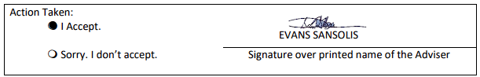

CC:

CICT Dean

Research Coordinator

Group

Appendix B

Letter to the English Editor

May 25, 2022

**SIMOUN OMAR DYLAN B. PADILLA**

Faculty, DEFLLS

West Visayas State University – Main Campus

Luna Street, La Paz, Iloilo City

Dear Sir Padilla,

We BSIT 4th year students of CICT of this university conducted our thesis/capstone project entitled **“Internet-of-Things Inventory Management System for Ultra-low Biofreezer in MQTT Framework”**.

Knowing your expertise in research, we would like to request you to be our **THESIS GRAMMARIAN.**

We believe that your expertise in this area will significantly improve and help us for the final presentation and format of our thesis worthy to serve as an example or basis for the other BSIT students in the future.

May we have your reply by May 30, 2022. Your positive response will mean a lot to us.

Respectfully yours,

1. Amio, Ayrra Jane R.

2. Castro, Mc Kelly D.

3. Sevilla, Winston C.

4. Soncio, Paul Adrian D.

5. Wong, Jose Mari C.

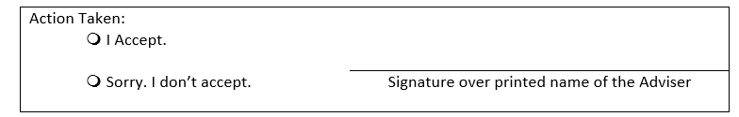

Appendix C

ISO 9126 Software Quality Evaluation Questionnaire

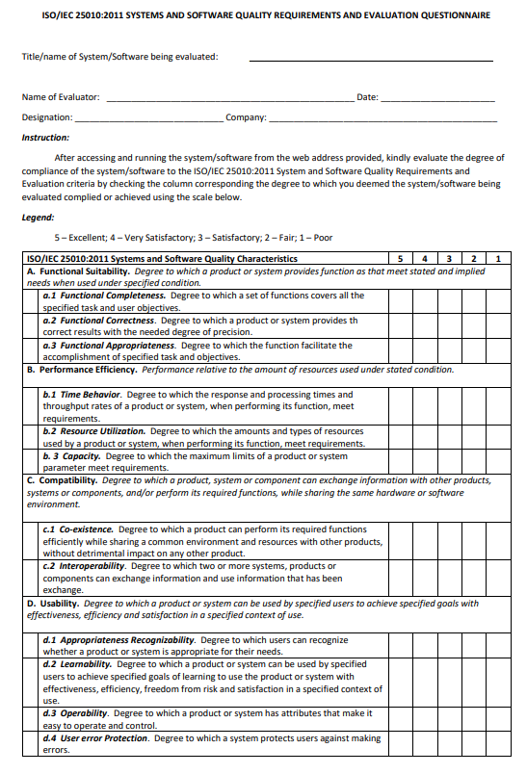

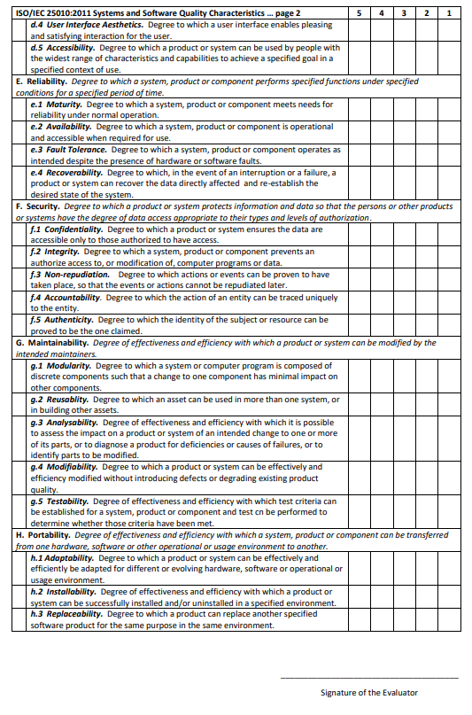

Appendix D

Certificate of Completion and Acceptance

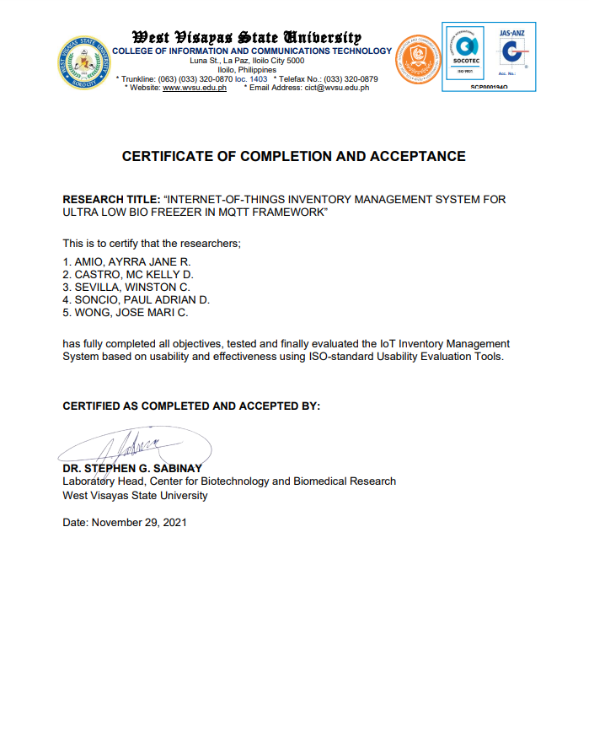

Appendix E

Gantt Chart

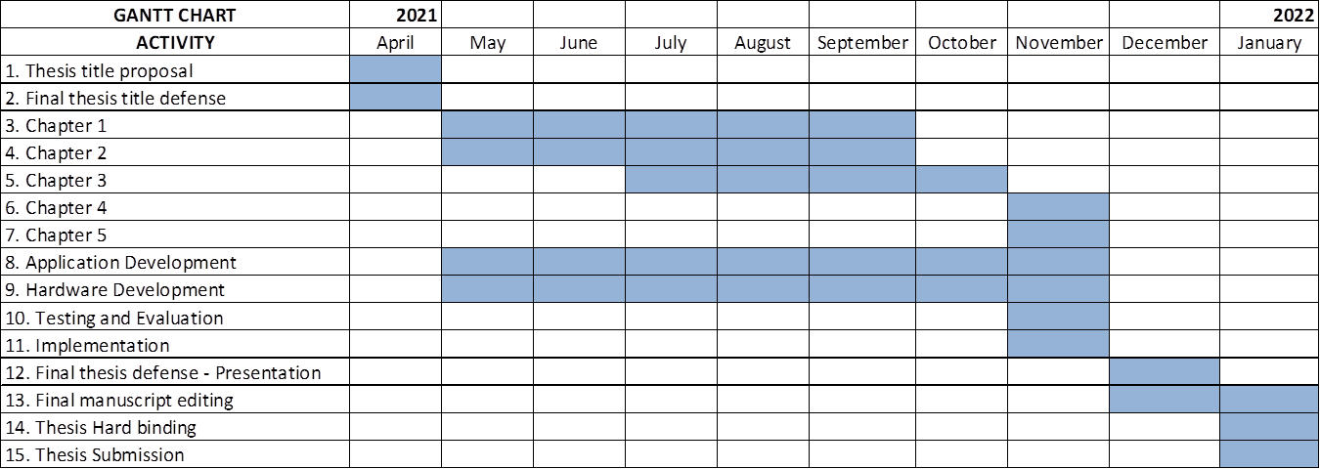

Appendix F

Entity Relationship Diagram

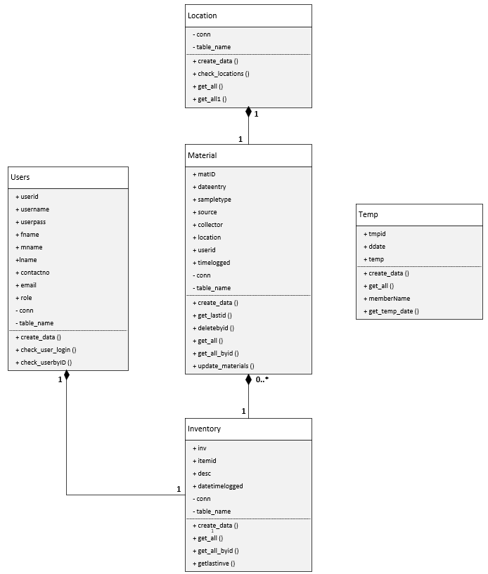

Appendix G

Data Dictionary

|  |  |
| --- | --- |
| tblusers | : userid + |
|  | username + |
|  | userpass + |
|  | fname + |
|  | mname + |
|  | lname + |
|  | contactno + |
|  | email + |
|  | role + |

|  |  |
| --- | --- |
| tblmaterials | : matID + |
|  | dateentry + |
|  | sampletype + |
|  | source + |
|  | collector + |
|  | location + |
|  | userid + |
|  | timelogged + |

|  |  |
| --- | --- |
| tblinventorydata | : inv + |
|  | itemid + |
|  | userid + |
|  | desc + |
|  | datetimelogged + |

|  |  |
| --- | --- |
| tbllocation | : locid + |
|  | loc_name + |
|  | val + |

|  |  |
| --- | --- |
| tbltemperature | : tmpid + |
|  | temp + |
|  | timelogged + |

Appendix H

Circuit Diagram

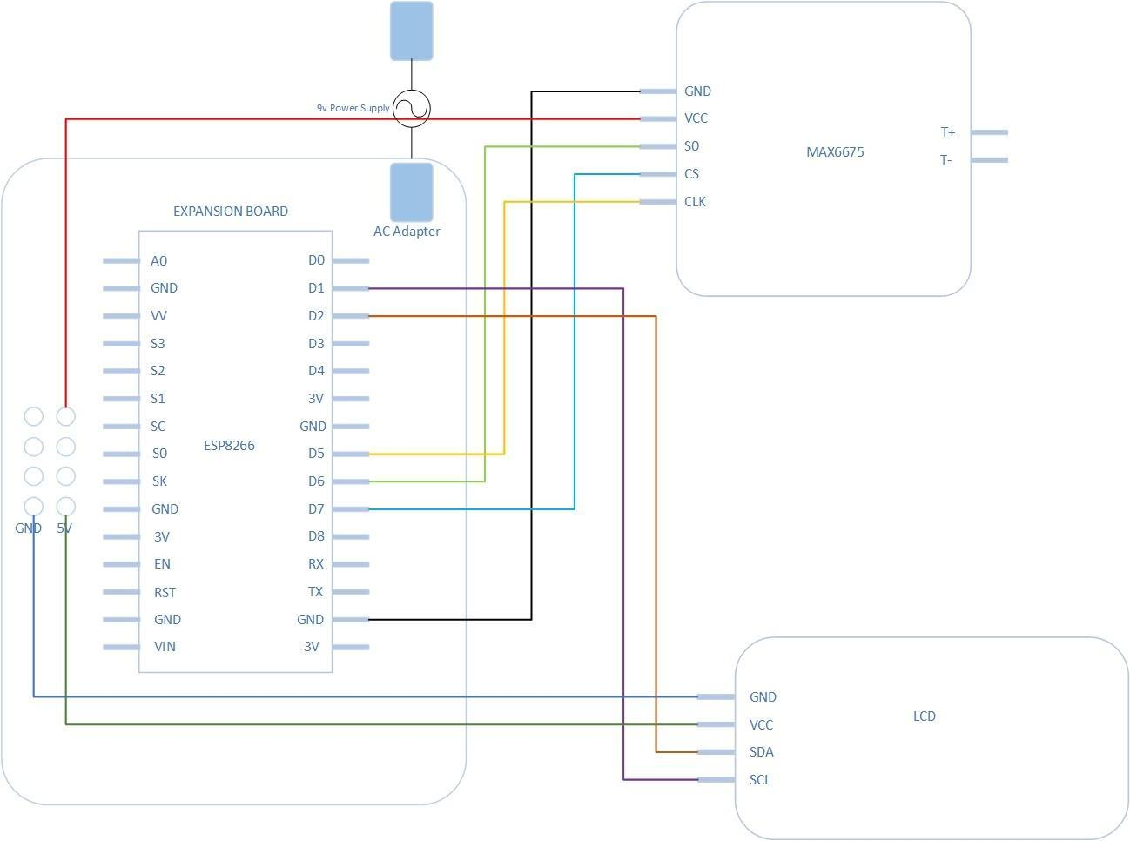

Appendix I

Sample Program Codes

**Final Arduino Code**

#include <ArduinoJson.h>

#include <ESP8266WiFi.h>

#include <ESP8266HTTPClient.h>

#include <max6675.h>

#include <Wire.h>

#include <LiquidCrystal_I2C.h>

#include <WiFiClientSecure.h>

//MQTT

#include <CayenneMQTTESP8266.h>

#define CAYENNE_DEBUG

#define CAYENNE_PRINT Serial

//Pin

int ktcSO=12; //GPIO 12 D6

int ktcCS=13; //GPIO 13 D7

int ktcCLK=14; // GPIO 14 D5

MAX6675 ktc(ktcCLK,ktcCS, ktcSO);

LiquidCrystal_I2C lcd(0x27,20,4);

//Declarations

const char* ssid = "";

const char* password = "";

//Cayenne Authentication info.

//This should be obtained from the Cayenne Dashboard

char username[] = "c56067c0-4cf9-11ec-ad90-75ec5e25c7a4";

char mqtt_password[] = "e5786f446e971cf800527c1c3b6af64e922d1a5f";

char client_id[] = "717fab10-4cfa-11ec-9f5b-45181495093e";

WiFiClientSecure client;

void setup() {

  Serial.begin(9600);

// Start the Serial communication to send messages to the computer

  delay(500);

  lcd.init();

//Initialize lcd screen --

  lcd.backlight();

//From LiquidCrystal_I2C library

  Serial.println('\n');

  WiFi.begin(ssid, password);

// Connect to the network

  Serial.print("Connecting to ");

  Serial.print(ssid); Serial.println(" ...");

  int i = 0;

  while (WiFi.status() != WL_CONNECTED) {

    // Wait for the Wi-Fi to connect

delay(1000);

Serial.print(++i);

Serial.print(' ');

Cayenne.begin(username, mqtt_password, client_id, ssid, password);

  }

  Serial.println('\n');

  Serial.println("Connection established!");

  Serial.print("IP address:\t");

  Serial.println(WiFi.localIP());

// Send the IP address of the ESP8266 to the computer

}

void loop() {

  if (WiFi.status() == WL_CONNECTED) {

//Check WiFi connection status

float tempData = ktc.readCelsius();

//converts data into float digits

lcd.print("C= ");                          lcd.print(ktc.readCelsius());              lcd.setCursor(0, 0);

Serial.print("C = ")

Serial.print(ktc.readCelsius());

Serial.print("\t");

Cayenne.virtualWrite(1, tempData, TYPE_TEMPERATURE, UNIT_CELSIUS);

WiFiClient client;

HTTPClient http;

http.begin(client,"http://192.168.254.103/bioapi/v1/addtemp.php");  //Specify request destination

    http.addHeader("Content-Type","application/json");

StaticJsonDocument<200> doc;

doc["temp"] = tempData;

String requestBody;

serializeJson(doc, requestBody);

int httpCode = http.POST(requestBody);

if (httpCode > 0) { //Check the returning code

   String payload = http.getString();

//Get the request response payload

      Serial.println(payload);

//Print the response payload

      Serial.println(tempData);

} else  {

        Serial.println("oops");

   }

http.end();   //Close connection

   }

  delay(10000); //Send a request every 5 seconds

}

**Gettemp class**

<?php

//include headers

header("Access-Control-Allow-Origin: *");

header("Content-type: application/json; charset: UTF-8");

header("Access-Control-Allow-Methods: GET");

//include database

include_once("../config/database.php");

//include users

include_once("../classes/temp.php");

$db = new Database();

$connection = $db->connect();

$Temp = new Temp($connection);

if($_SERVER['REQUEST_METHOD'] === "GET") {

}

else {

http_response_code(500); //404 service not available

echo json_encode(

array(

Status" => 0,

"Message" => "ss Error"

)

);

}

?>

**Inventory class**

<?php

class Inventory{

public $inv;

public $itemid;

public $userid;

public $desc;

public $datetimelogged;

private $conn;

private $table_name;

public function  __construct($db){

$this->conn = $db;

$this->table_name = "tblinventorydata";

}

    //INSERT inventory

public function create_data(){

        $query = 'INSERT INTO '. $this->table_name.' SET itemid = ? , userid= ? , `desc` = ? , datetimelogged = ? ';

        // prepare sql

        $obj = $this->conn->prepare($query);

        // binding parameters with prepare statement

        $obj->bind_param("iiss" ,  $this->itemid , $this->userid ,  $this->desc ,   $this->datetimelogged  );

        if($obj->execute()) {

            return true;

        }

        return false;

    }

    public function get_all() {

        $sql_query = "SELECT inv, sampletype,`desc`,datetimelogged ,concat(lname,', ',fname) as name FROM tblinventorydata inner join tblmaterials on matid = itemid inner join tblusers on tbl materials.user id = tblusers.userid" ;

        $std_obj = $this->conn->prepare($sql_query);

        $std_obj->execute();

        return $std_obj->get_result();

    }

    public function get_all_byid() {

        $sql_query = "SELECT inv, itemid, sampletype,`desc`,datetimelogged ,concat(lname,', ',fname) as name FROM tblinventorydata inner join tblmaterials on matid = itemid inner join tblusers on tbl inventory data.user id = tblusers.userid where itemid = ? " ;

        $std_obj = $this->conn->prepare($sql_query);

        $std_obj->bind_param("i",  $this->itemid  );

        $std_obj->execute();

        return $std_obj->get_result();

    }

    public function getlastinve() {

        $sql_query = 'select inv, `desc` from tblinventorydata where itemid = ? order by inv desc limit 1';

        $std_obj = $this->conn->prepare($sql_query);

        $std_obj->bind_param("i",  $this->itemid  );

        $std_obj->execute();

        return $std_obj->get_result();

    }

}

?>

**Location class**

<?php

class Location{

private $conn;

private $table_name;

public function  __construct($db){

$this->conn = $db;

$this->table_name = "tbl_location";

}

    //INSERT EMPLOYEES

public function create_data(){

        $query = 'INSERT INTO '. $this->table_name.' SET username = ? , userpass = ? , fname = ?, mname = ? , lname = ?, contactno = ?,email = ?, role = ? ';

        // prepare sql

        $obj = $this->conn->prepare($query);

        // sanitize variables

        $this->username = htmlspecialchars(strip_tags($this->username));

        $this->userpass = md5(htmlspecialchars(strip_tags($this->userpass)));

        $this->fname = htmlspecialchars(strip_tags($this->fname));

        $this->mname = htmlspecialchars(strip_tags($this->mname));

        $this->lname = htmlspecialchars(strip_tags($this->lname));

        $this->contactno = htmlspecialchars(strip_tags($this->contactno));

        $this->email = htmlspecialchars(strip_tags($this->email));

        $this->role = htmlspecialchars(strip_tags($this->role));

        //binding parameters with prepare statement

        $obj->bind_param("ssssssss" ,  $this->username ,  $this->userpass, $this->fname ,  $this->mname ,  $this->lname, $this->contactno ,  $this->email , $this->role );

        if($obj->execute()) {

            return true;

        }

        return false;

    }

    public function check_locations() {

        $query = 'SELECT locid, loc_name , if(location is null , 0 , location) as loc FROM tbl_location left join tblmaterials on locid = tbl materials.location';

        $obj = $this->conn->prepare($query);

        if($obj->execute()){

            $data = $obj->get_result();

            return $data->fetch_assoc();

        }

        return array();

    }

    public function get_all() {

        $sql_query = "SELECT locid, loc_name , if(location is null , 0 , location) as loc FROM tbl_location left join tblmaterials on locid = tbl materials.location where location is null" ;

        $std_obj = $this->conn->prepare($sql_query);

        $std_obj->execute();

        return $std_obj->get_result();

    }

    public function get_all1() {

        $sql_query = "SELECT locid, loc_name , if(location is null , 'white' , '#68AF69') as loc FROM tbl_location left join tblmaterials on locid = tbl materials.location" ;

        $std_obj = $this->conn->prepare($sql_query);

        $std_obj->execute();

      return $std_obj->get_result();

    }

}

?>

**Material class**

<?php

class Material{

public $matID;

public $dateentry;

public $sampletype;

public $source;

public $collector;

public $location;

public $user id;

public $timelogged;

private $conn;

private $table_name;

public function  __construct($db){

$this->conn = $db;

$this->table_name = "tblmaterials";

}

    //INSERT materials

public function create_data(){

        $query = 'INSERT INTO '. $this->table_name.' SET dateentry = ? , sampletype= ? , source = ? , collector = ? , location = ? , userid = ?';

        // prepare sql

        $obj = $this->conn->prepare($query);

        //binding parameters with prepare statement

        $obj->bind_param("sssssi" ,  $this->dateentry , $this->sampletype ,  $this->source ,   $this->collector , $this->location ,  $this->userid );

        if($obj->execute()) {

            return true;

        }

        return false;

    }

    public function get_lastid() {

        $sql_query = 'CALL procGetLastID()';

        $std_obj = $this->conn->prepare($sql_query);

        $std_obj->execute();

        return $std_obj->get_result();

    }

    public function deletebyid() {

        $sql_query = 'delete from tblmaterials where matID = ?';

        $std_obj = $this->conn->prepare($sql_query);

        $std_obj->bind_param("i",  $this->matID  );

        $std_obj->execute();

        return $std_obj->get_result();

    }

    public function get_all() {

        $sql_query = "SELECT matID, dateentry, sampletype, source, collector , loc_name  FROM tblmaterials inner join tbl_location on tbl_location.locid = tblmaterials.location" ;

        $std_obj = $this->conn->prepare($sql_query);

        $std_obj->execute();

        return $std_obj->get_result();

    }

    public function get_all_byid() {

        $sql_query = "SELECT matID, dateentry, sampletype, source, collector , loc_name  FROM tblmaterials inner join tbl_location on tbl_location.locid = tblmaterials.location where matID = ?" ;

        $std_obj = $this->conn->prepare($sql_query);

        $std_obj->bind_param("i",  $this->matID  );

        $std_obj->execute();

        return $std_obj->get_result();

    }

    public function update_materials() {

        $sql_query = "Update tblmaterials SET dateentry= ? , sampletype = ?, source = ?, collector = ? where matID = ?" ;

        $std_obj = $this->conn->prepare($sql_query);

        $std_obj->bind_param("ssssi",   $this->dateentry ,  $this->sampletype ,  $this->source , $this->collector ,   $this->matID  );

        $status = $std_obj->execute() or die ($std_obj->error);

        return $std_obj->get_result();

    }

}

?>

**Temp class**

<?php

class Temp{

public $tmpid;

public $temp;

public $ddate;

private $conn;

private $table_name;

public function  __construct($db){

$this->conn = $db;

$this->table_name = "tbltemperature";

}

    //INSERT EMPLOYEES

public function create_data(){

        $query = 'INSERT INTO '. $this->table_name.' SET temp = ?';

        // prepare sql

        $obj = $this->conn->prepare($query);

        // binding parameters with prepare statement

        $obj->bind_param("d" ,  $this->temp );

        if($obj->execute()) {

            return true;

        }

        return false;

    }

    public function get_all() {

        $sql_query = "SELECT * FROM tbltemperature  " ;

        $std_obj = $this->conn->prepare($sql_query);

        $std_obj->execute();

        return $std_obj->get_result();

    }

    public function get_temp_date() {

        $sql_query = " SELECT temp as  y, timelogged as x, tmpid FROM tbltemperature where date(timelogged) = ?" ;

        $std_obj = $this->conn->prepare($sql_query);

        $std_obj->bind_param("s" ,  $this->ddate  );

        $std_obj->execute();

        return $std_obj->get_result();

    }

}

?>

**Users class**

<?php

class Users{

public $userid;

public $username;

public $userpass;

public $fname;

public $mname;

public $lname;

public $contactno;

public $email;

public $role;

private $conn;

private $table_name;

public function  __construct($db){

$this->conn = $db;

$this->table_name = "tblusers";

}

    //INSERT EMPLOYEES

public function create_data(){

        $query = 'INSERT INTO '. $this->table_name.' SET username = ? , userpass = ? , fname = ?, mname = ? , lname = ?, contactno = ?,email = ?, role = ? ';

        // prepare sql

        $obj = $this->conn->prepare($query);

        // sanitize variables

        $this->username = htmlspecialchars(strip_tags($this->username));

        $this->userpass = md5(htmlspecialchars(strip_tags($this->userpass)));

        $this->fname = htmlspecialchars(strip_tags($this->fname));

        $this->mname = htmlspecialchars(strip_tags($this->mname));

        $this->lname = htmlspecialchars(strip_tags($this->lname));

        $this->contactno = htmlspecialchars(strip_tags($this->contactno));

        $this->email = htmlspecialchars(strip_tags($this->email));

        $this->role = htmlspecialchars(strip_tags($this->role));

        // binding parameters with prepare statement

        $obj->bind_param("ssssssss" ,  $this->username ,  $this->userpass, $this->fname ,  $this->mname ,  $this->lname, $this->contactno ,  $this->email , $this->role );

        if($obj->execute()) {

            return true;

        }

        return false;

    }

    public function check_user_login() {

        $query = 'SELECT * FROM ' .$this->table_name. ' where username = ? and userpass = ?';

        $obj = $this->conn->prepare($query);

        $this->userpass = md5($this->userpass);

        $obj->bind_param("ss" , $this->username, $this->userpass);

        if($obj->execute()){

            $data = $obj->get_result();

            return $data->fetch_assoc();

        }

        return array();

    }

    public function check_user_login_admin() {

        $query = 'SELECT * FROM ' .$this->table_name. ' where username = ? and userpass = ? and role = "Admin"';

        $obj = $this->conn->prepare($query);

        $this->userpass = md5($this->userpass);

        $obj->bind_param("ss" , $this->username, $this->userpass);

        if($obj->execute()){

            $data = $obj->get_result();

            return $data->fetch_assoc();

        }

        return array();

    }

    public function check_userbyID() {

        $query = 'SELECT * FROM ' .$this->table_name. ' where empid = ?';

        $obj = $this->conn->prepare($query);

        $obj->bind_param("i" , $this->empid);

        if($obj->execute()){

            $data = $obj->get_result();

            return $data->fetch_assoc()

        }

        return array();

    }

}

?>

Disclaimer

This software project and its corresponding documentation entitled “IOT INVENTORY MANAGEMENT SYSTEM FOR ULTRA-LOW BIOFREEZER IN MQTT FRAMEWORK” is submitted to the College of Information and Communications Technology, West Visayas State University, in partial fulfillment of the requirements for the degree, Bachelor of Science in Information Technology. It is the product of our own work, except where indicated text.

We hereby grant the College of Information and Communications Technology permission to freely use, publish in local or international journal/conferences, reproduce, or distribute publicly the paper and electronic copies of this software project and its corresponding documentation in whole or in part, provided that we are acknowledged.

AYRRA JANE R. AMIO

MC KELLY D. CASTRO

WINSTON C. SEVILLA

PAUL ADRIAN D. SONCIO

JOSE MARI C. WONG

JUNE 2022